**Deliverable 4:**

1. **Report Requirements:**

**List of Functional and Non-Functional Requirements for Development Phase 2:**

**1. Back-end REST API Development Functional Requirements:**

**1.1 View Order Details:** Once the customer completes the payment successfully, the paymentId and payment Status would come from PayPal integration services. If the payment status is successful, orderId and order Status would get stored in PaymentInfo table and the columns would be amount, currency, orderId, order Status, payer Id, payment Id and payment Status.

**1.2 Order Tracking**: When customer send the request of trackingId from UI, the back end API would get triggered. The API endpoint is unique and exposed in PaymentInfo Controller layer. It is available in track Order API. The back end database call would get triggered from service layer to PaymentInfo repository layer, where PaymentInfo related details are fetched based on orderId.

**1.3 Responsibilities of Store Owner**: The store owner would have access to entire products and inventories. The store owner access level and permissions are explained below.

**1.3.1 Add Products in Store**: When store owner sends the request by sending Product object from UI, the back end API would get triggered. The API endpoint is unique and exposed in Product Controller layer. It is available in add Product API. The back end database call would get triggered from service layer to Products repository layer, where the new Product object is persisted into database and successful message would be sent back as response.

**1.3.2 Update Products in Store:** When store owner sends the request by sending Product object from UI, the back end API would get triggered. The API endpoint is unique and exposed in Product Controller layer. It is available in update Product API. The back end database call would get triggered from service layer to Products repository layer, where the existing Product object is updated in database if the Product ID is present, and successful message would be sent back as response.

**1.3.3 Delete Products in Store:** When owner sends the request by sending Product ID from UI, the back end API would get triggered. The API endpoint is unique and exposed in Product Controller layer. It is available in delete Product API. The back end database call would get triggered from service layer to Products repository layer, where the existing Product object is deleted in database if the Product ID is present, and successful message would be sent back as response.

**1.3.4 Add Products to the Inventory**: When owner sends the request by sending Product ID and quantity from UI, the back end API would get triggered. The API endpoint is unique and exposed in Employee Controller layer. It is available in addOrUpdateProduct API. The back end database call would get triggered from service layer to Inventory repository layer, where the new Product would get added to the Inventory as the current inventory did not have this product available. It would get persisted into Inventory entity as new entry with sent Product ID and quantity.

**1.3.5 Update Products Quantity to the Inventory**: When owner sends the request by sending Product ID and quantity from UI, the back end API would get triggered. The API endpoint is unique and exposed in Employee Controller layer. It is available in addOrUpdateProduct API. The back end database call would get triggered from service layer to Inventory repository layer, where the existing Product would get updated to the Inventory as the current inventory already have this product available. It would get persisted into Inventory entity by updating the quantity of the existing product with sent Product ID and quantity.

**1.4 Responsibilities of Store Manager**: The store Manager would have access to entire inventory. The store Manager access level and permissions are explained below.

**1.4.1 Add Products to the Inventory**: When owner sends the request by sending Product ID and quantity from UI, the back end API would get triggered. The API endpoint is unique and exposed in Employee Controller layer. It is available in addOrUpdateProduct API. The back end database call would get triggered from service layer to Inventory repository layer, where the new Product would get added to the Inventory as the current inventory did not have this product available. It would get persisted into Inventory entity as new entry with sent Product ID and quantity.

**1.4.2 Update Products Quantity to the Inventory**: When owner sends the request by sending Product ID and quantity from UI, the back end API would get triggered. The API endpoint is unique and exposed in Employee Controller layer. It is available in addOrUpdateProduct API. The back end database call would get triggered from service layer to Inventory repository layer, where the existing Product would get updated to the Inventory as the current inventory already have this product available. It would get persisted into Inventory entity by updating the quantity of the existing product with sent Product ID and quantity.

**1.5 Responsibilities of Assistant Employee:** The assistant employee would assist the customer who opts for in-store pickup.

**1.5.1 Get Assistant Employee to Assist Customer**: When customer opts for in-store pickup, the back end API would get triggered. The API endpoint is unique and exposed in Employee Controller layer. It is available in getAssistant API. The back end database call would get triggered from service layer to Employee repository layer, where all the existing employees of type ‘Assistant Employee’ are fetched. One of the random employee from the fetched list would be sent back as response and him/her would assist the customer.

**1.6 Add/Update Products in Inventory**: Store Owner and Store Manager can access the inventory and owner or the manager would send the Product ID and quantity from UI. If the productID exists in the inventory table, quantity would get updated for the existing product in DB. If the productID does not exist in inventory, new product would be added to the inventory table.

**1.7 Updating and Deletion of Products**: Store owner can access the inventory and when owner sends the updated details of the product, the product would get updated in the products entity. When owner sends the product ID for the deletion of product, the product with the respective Product ID would get deleted from the database.

2. **Functional Requirements for Designing Front end UI screens and Integration with  Back-end API:**

**2.1 View Order Details**: Order Details Component is created in pages folder and specific route is created to navigate to that web page. Once the payment is successful, the user would land on order details screen, where user can view the ordered products, orderID and order Status.

**2.2 Order Tracking:** Track Order Details link is added in dashboard nav bar. When user clicks on it, the user would land on Order Tracking components page which is created in pages folder and specific route is created to navigate to that web page. When user provides the tracking ID as input, the order details would get rendered and the details consists of amount, currency, payerID, payment Status, orderID and order Status.

**2.3 Responsibilities of Store Owner**: Once employee is successfully authenticated, based on his access permissions, owner can see manage inventory and manage products in employee Nav bar once owner lands on employee dashboard.

**2.3.1 Add Products in Store:** When owner clicks on manage products from the nav bar, the user would land on Manage Products component, where the user can view all the available products with add new product, update product, and delete product buttons for each product. When user clicks on add product button, we would land on Post Products component web page. Once user provides all the product details, the request would go to back end and if the request is successful the user would land on dashboard page.

**2.3.2 Update Products in Store**: When owner clicks on manage products from the nav bar, the user would land on Manage Products component, where the user can view all the available products with add new product, update product, and delete product buttons for each product. When user clicks on update product button, we would land on Update Products component web page. Once user provides all the product details, the request would go to back end and if the request is successful the user would land on dashboard page.

**2.3.3 Delete Products in Store**: When owner clicks on manage products from the nav bar, the user would land on Manage Products component, where the user can view all the available products with add new product, update product, and delete product buttons for each product. When user clicks on delete product button, the request would go to back end and if the request is successful the user would land on dashboard page.

**2.3.4 Add Products to the Inventory:** When owner clicks on manage inventory from the nav bar, the user would land on Update Inventory component, where user can view all the available products and add/update product in Inventory button. If the user clicks on it, a pop up would be opened, where it would ask for quantity. If the user clicks on submit button, the request would go to back end and it would add new product to the inventory and if the request is successful, user would land on employee dashboard page.

**2.3.5 Update Products to the Inventory**: When owner clicks on manage inventory from the nav bar, the user would land on Update Inventory component, where user can view all the available products and add/update product in Inventory button. If the user clicks on it, a pop up would be opened, where it would ask for quantity. If the user clicks on submit button, the request would go to back end and it would update quantity for the existing product in the inventory and if the request is successful, user would land on employee dashboard page.

**2.4 Responsibilities of Store Manager**: Once employee is successfully authenticated, based on his access permissions, manager can see manage inventory in employee Nav bar once owner lands on employee dashboard.

**2.4.1 Add Products to the Inventory**: When manager clicks on manage inventory from the nav bar, the user would land on Update Inventory component, where user can view all the available products and add/update product in Inventory button. If the user clicks on it, a pop up would be opened, where it would ask for quantity. If the user clicks on submit button, the request would go to back end and it would add new product to the inventory and if the request is successful, user would land on employee dashboard page.

**2.4.2 Update Products to the Inventory**: When manager clicks on manage inventory from the nav bar, the user would land on Update Inventory component, where user can view all the available products and add/update product in Inventory button. If the user clicks on it, a pop up would be opened, where it would ask for quantity. If the user clicks on submit button, the request would go to back end and it would update quantity for the existing product in the inventory and if the request is successful, user would land on employee dashboard page.

**2.5 Responsibilities of Assistant Employee:**

**2.5.1 Get Assistant Employee to Assist Customer**: When customer opts for add to store pickup option in product details component, the products get added into the cart. Once customer completes the payment and lands on order details page, the customer can see assistant employee details like employee’s full Name, email ID and mobile Number.

**2.6 Add/Update Products in Inventory**: When owner/ manager clicks on manage inventory button from the nav bar, the user would land on Update Inventory component which is available in pages folder and specific route is created to navigate to this web page. The user can manage inventory by adding and updating the products quantity in the inventory.

**2.7 Updating and Deletion of Products:** When owner clicks on manage products button from the nav bar, the user would land on Manage Products component which is available in pages folder and specific route is created to navigate to this web page. The user can manage products by deleting and updating the products in the store.

**3. Other Non-Functional Requirements:**

**3.1  Code reviews and merge requests for phase 2 developed code:** Code reviews are done for all the code changes which was raised by all team members and the code got merged into main branch. All the functional requirements which were planned for development phase 2 are raised for code merge requests.

**3.2 Code deployment  for phase 2 developed code:** The code which got pushed into main branch is deployed into azure cloud VM. The latest code from main branch is pulled into VM. The updated docker images are created for both back end and front end. The docker containers are restarted with the latest docker images and the containers are up and running.

**3.3 Compatibility:** The application has cross-platform compatibility which ensures software functions across different environments. The application has browser compatibility which ensures consistent user experience across various web browsers. Dependency management is done efficiently by using docker which would automate the deployment.

**3.4 Maintainability:** The code is organized into modules based on its functionality. The code is reused to avoid duplicity. The code is easy to extend and customize the code modules. Proper naming conventions, coding guidelines and design patterns are followed for code readability and maintainability.

**B. Report UML:**

**Class Diagram:**

This development phase includes all important functionalities of employees. The classes like Inventory, Product, Location and Employee are used. The other customer functionalities are also included in this phase. The classes used are Customer and PaymentInfo. Multiple products can be part of single inventory. So, the mapping between products and inventory is Many to One. Multiple locations can be part of an inventory. So, the mapping between locations and inventory is Many to One. One customer can perform multiple payments and can view/ track order details if the payment is successful. So, the mapping between customer and payments is One to Many. Customer and Employee would login into the application. The mapping between customer and user is One to One bidirectional and the mapping between employee and user is One to One bidirectional. The class diagram is attached below.

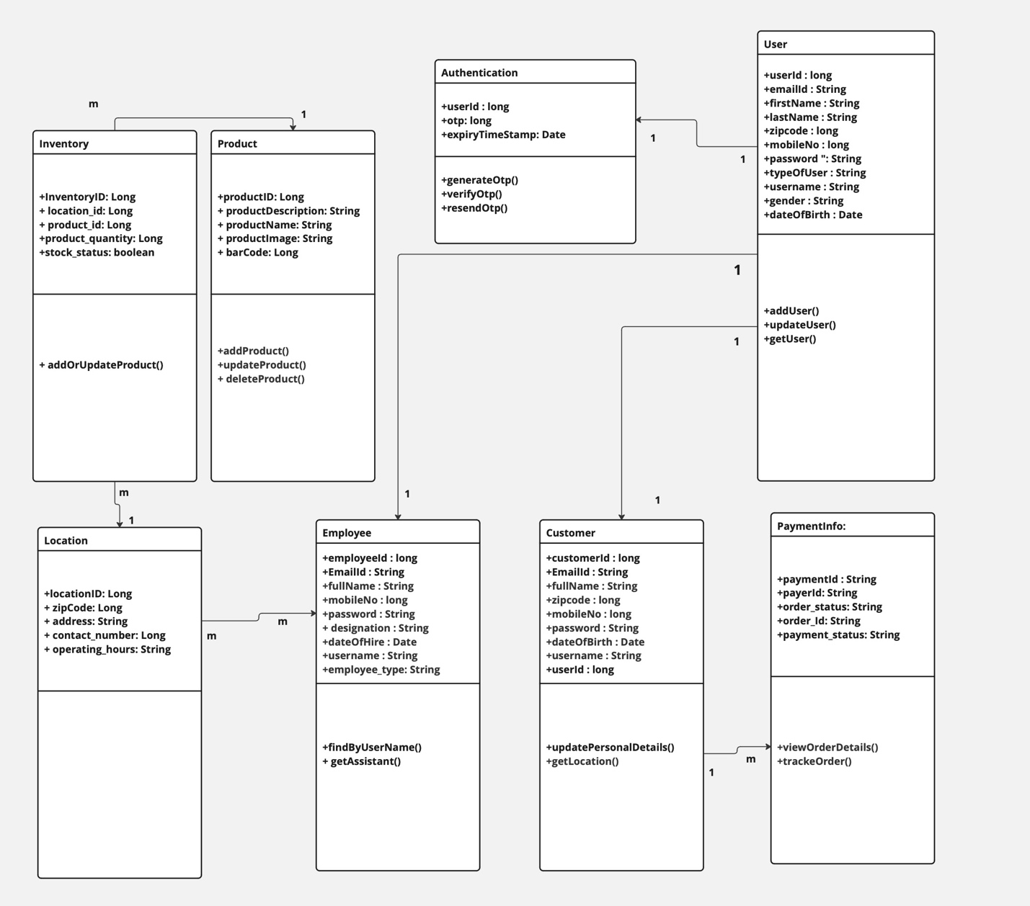

**Sequence Diagram:**

Once the customer logs into the application, the customer would land on dashboard page. The customer can view order details once the payment is successful. The customer can also track order details by providing trackingID. Once the employee logs into the application, the employee would land on employee dashboard page. The employee can add, update, and delete products in store. The employee can also update product quantity in the inventory, add products to the inventory. The employee would also assist customer who opts for in-store pickup.

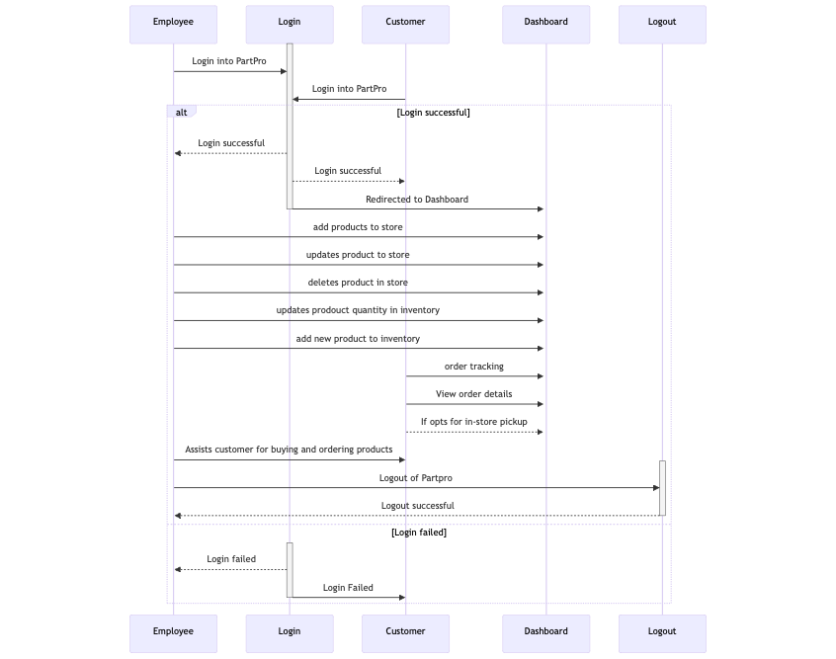

**Use Case Diagram:**

The actors would be employee and customer. The employee would perform various actions like add Product, delete Product, update Product, add Products to the inventory, update product quantity to inventory and assists customer. The customer would perform actions like view order sales, track orders by orderID. The negative error use case diagram includes various actions of exception handling like if the trackingID is invalid, the customer cannot track order details. If the productID is invalid, the employee cannot delete, update product, update product quantity in inventory.

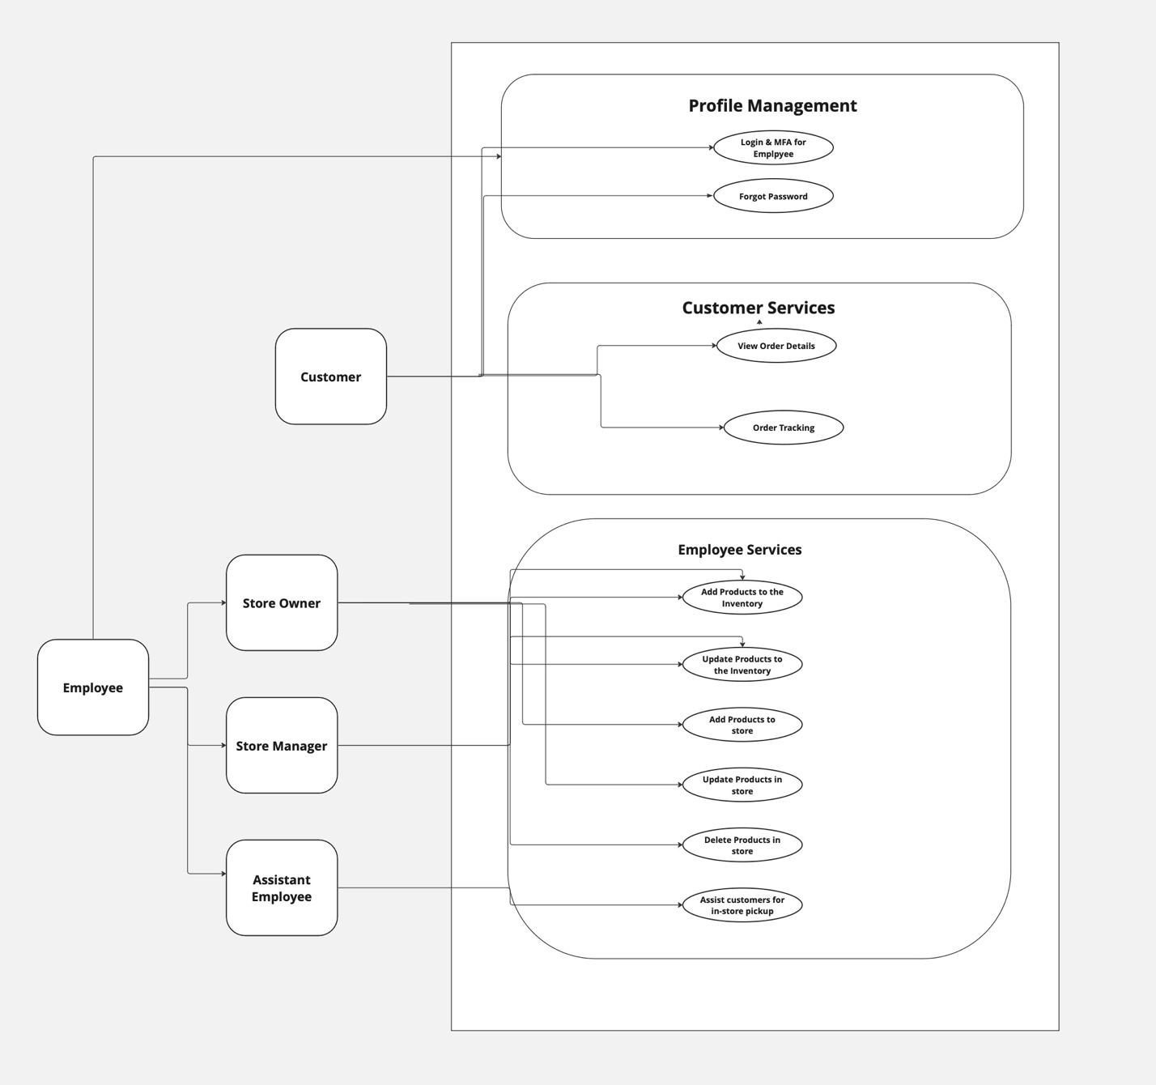

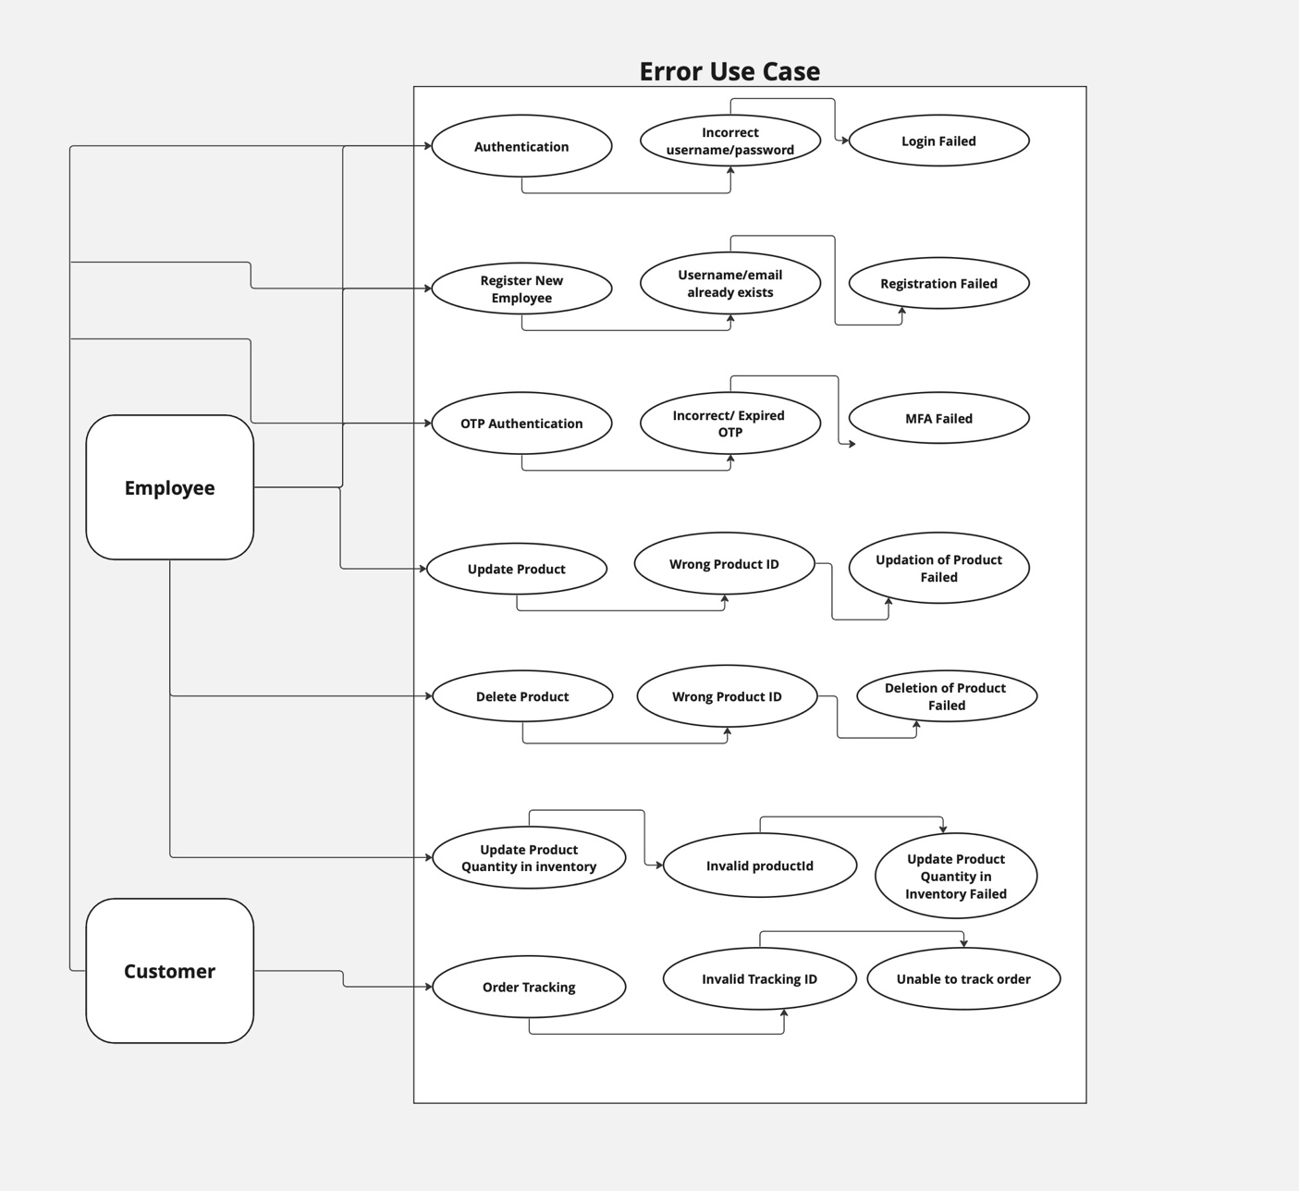

**C. Report Test Cases:**

I have written test cases and tested features which were developed as part of development phase 2. The test cases are written for better code quality and code coverage. The test cases are written for all the controller endpoints which were exposed in Controller layer.

**Test Case 1: ‘testAddOrUpdateProduct:**

**Purpose**: This test aims to verify the functionality of the addOrUpdateProduct method in handling the addition or updating of products in the inventory.

**Functionality Under Test**: The test checks if the method correctly adds a new product or updates an existing product based on the provided productId and quantity.

**Test Steps:**

1. Mock the employeeService.addOrUpdateProduct method to return a success message.
2. Perform a POST request to the /ppms/employee/addOrUpdateProduct endpoint with productId and quantity as parameters.
3. Assert that the HTTP response status is OK (200).
4. Assert that the response content matches the expected success message.

**Expected Inputs:**

1. productId: 1L (Long)
2. quantity: 10(Integer)

**Expected Outputs:** A success message, "Product added or updated successfully", confirming the correct execution of the add or update operation.

**Test Case 2: ‘testFindByUserName’:**

**Purpose:** To validate whether the findByUserName method correctly retrieves an employee's details based on their username.

**Functionality Under Test:** The test confirms that the method fetches and returns the correct EmployeeDTO when provided with a specific username, ensuring the method's capability to retrieve user-specific data.

**Test Steps:**

1. Prepare an EmployeeDTO object with test data (designation set to "store_manager").
2. Mock the employeeService.findEmployeeByUserName method to return this EmployeeDTO for a given username.
3. Perform a GET request to the /ppms/employee/findByUserName endpoint with the userName parameter.
4. Assert that the HTTP response status is OK (200).
5. Assert that the response content matches the JSON representation of the mocked EmployeeDTO.

**Expected Inputs:**

1. userName: "testUser" (String)

**Expected Outputs:** JSON representation of EmployeeDTO containing the designation "store_manager", confirming correct retrieval based on the username.

**Test Case 3: ‘testGetAssistant’**:

**Purpose:** To ensure the getAssistant method correctly fetches the details of an assistant employee.

**Functionality Under Test:** This test checks if the method retrieves an EmployeeDTO representing an assistant employee, confirming the method's effectiveness in getting specific employee data.

**Test Steps:**

1. Prepare an EmployeeDTO object and set its designation as "assistant_employee".
2. Mock the employeeService.findAssistantEmployee to return this EmployeeDTO.
3. Perform a GET request to /ppms/employee/getAssistant.
4. Assert that the response status is OK (HttpStatus.OK).
5. Assert that the response content is the JSON representation of the EmployeeDTO.

**Expected Inputs:** None (no parameters passed to the method).

**Expected Outputs:** A JSON response that matches the EmployeeDTO object, specifically one representing an assistant employee.

**Test Case 4: ‘testTrackOrder’:**

**Purpose:** To validate that the trackOrder method successfully retrieves payment information for a given tracking ID.

**Functionality Under Test:** The test checks whether the method effectively returns the PaymentInfo associated with the specified tracking ID, ensuring its ability to track orders accurately.

**Test Steps:**

1. Initialize a PaymentInfo object with test data.
2. Mock the paymentInfoService.getByOrderId method to return this PaymentInfo for a specific tracking ID.
3. Perform a GET request to /ppms/payment/trackorderdetails/{trackingId} with the trackingId.
4. Assert that the HTTP response status is OK (200).
5. Assert that the response content matches the JSON representation of PaymentInfo.

**Expected Inputs:**

trackingId: "123" (String)

**Expected Outputs:** A JSON response matching the PaymentInfo object's state, confirming the accurate retrieval of order tracking information.

**Test Case 5: ‘testUpdateProduct’:**

**Purpose:** To confirm that the updateProduct method accurately updates a product's details in the system.

**Functionality Under Test:** This test verifies the ability of the method to update a product's information using ProductsDTO and return a success message.

**Test Steps:**

1. Create and set up a ProductsDTO object with sample product details.
2. Mock the productService.updateProductInfo method to return a success message for the provided ProductsDTO.
3. Perform a PUT request to /ppms/product/updateProduct with the ProductsDTO object as JSON content.
4. Assert that the response status is OK (200) and the content matches the expected success message.

**Expected Inputs:**

1. productDTO with "test product" description and "test" name.

**Expected Outputs**: A response message "Product Details updated successfully", confirming the product update.

**Test Case 6: ‘testDeleteProduct’**:

**Purpose:** To validate that the deleteProduct method effectively removes a product from the system using its product ID.

**Functionality Under Test:** This test ensures that upon passing a valid product ID to the method, the product is successfully deleted, and a confirmation message is returned.

**Test Steps:**

1. Mock the productService.deleteProduct method to return a success message when a specific product ID is provided.
2. Perform a DELETE request to /ppms/product/deleteProduct/{productId} with the given product ID.
3. Assert that the response status is OK (200).
4. Assert that the response content is a success message indicating successful deletion.

**Expected Inputs:**

1. productId: 1L (long)

**Expected Outputs**: A success message "Product deleted successfully" indicating that the product has been removed from the system.

**Test Case 7: ‘testAddProduct’:**

**Purpose**: To ensure that the addProduct method correctly adds a new product to the system.

**Functionality Under Test:** This test verifies the method's ability to accept a ProductsDTO object, add the product's details to the system, and return a confirmation message.

**Test Steps:**

1. Prepare a ProductsDTO object with the necessary test data.
2. Mock the productService.addProduct method to return a success message.
3. Perform a POST request to /ppms/product/addProduct with the ProductsDTO object serialized to JSON.
4. Assert that the response status is OK (200).
5. Optionally, assert that the response content matches the expected success message.

**Expected Inputs:** A ProductsDTO object containing the product details.

**Expected Outputs:** An OK status response from the server, confirming that the product has been successfully added.

All the test cases are running successfully and the above mentioned test cases are written in Payment Controller Test, Employee Controller Test and Product Controller Test. Below is the execution snapshot of all the test cases.

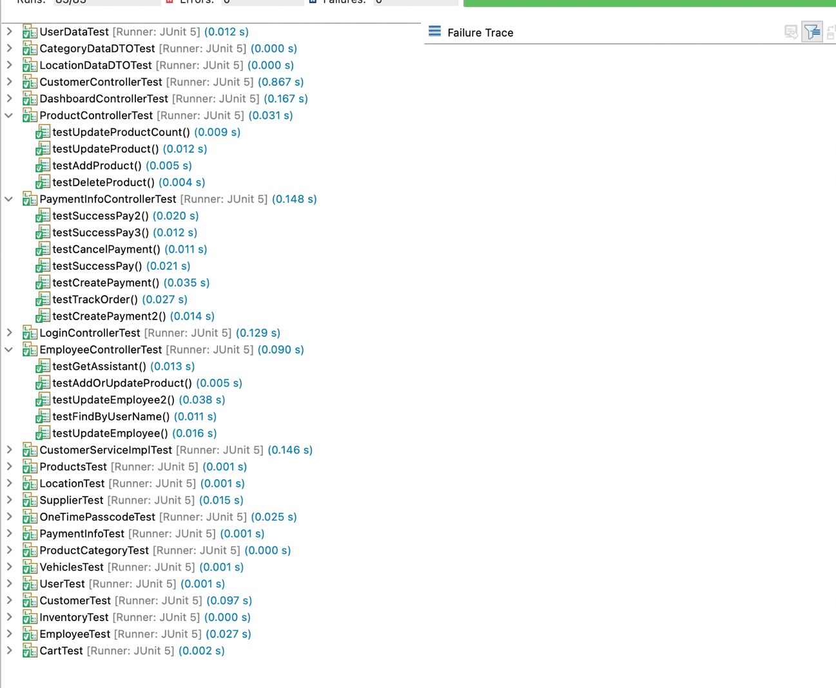

1. **Report Compilation Instructions**:

**For Backend:**

1. Install eclipse from the below link. If the OS is of windows, install it from below link.

<https://www.eclipse.org/downloads/download.php?file=/technology/epp/downloads/release/2024-03/R/eclipse-jee-2024-03-R-win32-x86_64.zip>

If the OS is of Mac, install is from below link.

<https://www.eclipse.org/downloads/download.php?file=/technology/epp/downloads/release/2024-03/R/eclipse-jee-2024-03-R-macosx-cocoa-aarch64.dmg>

1. Install the java development kit for getting java environment. Install it from below link.

<https://www.oracle.com/java/technologies/javase/jdk21-archive-downloads.html>

Install java of version 21.0.2 based on OS type.

1. Install MySQL workbench from the below link.

<https://dev.mysql.com/downloads/workbench/>

Install MySQL Workbench 8.0.36 based on OS type.

1. Once the code is imported successfully, update the maven project which would refresh the back-end code. 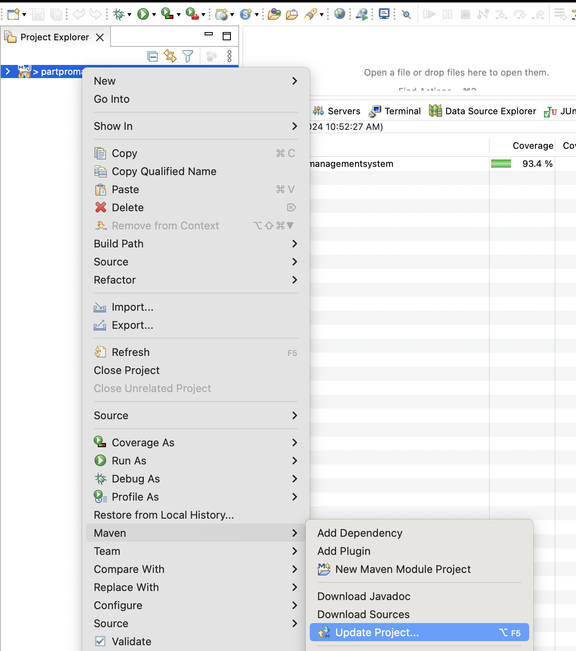
2. Compile and build the project by using maven build option and click on Run.

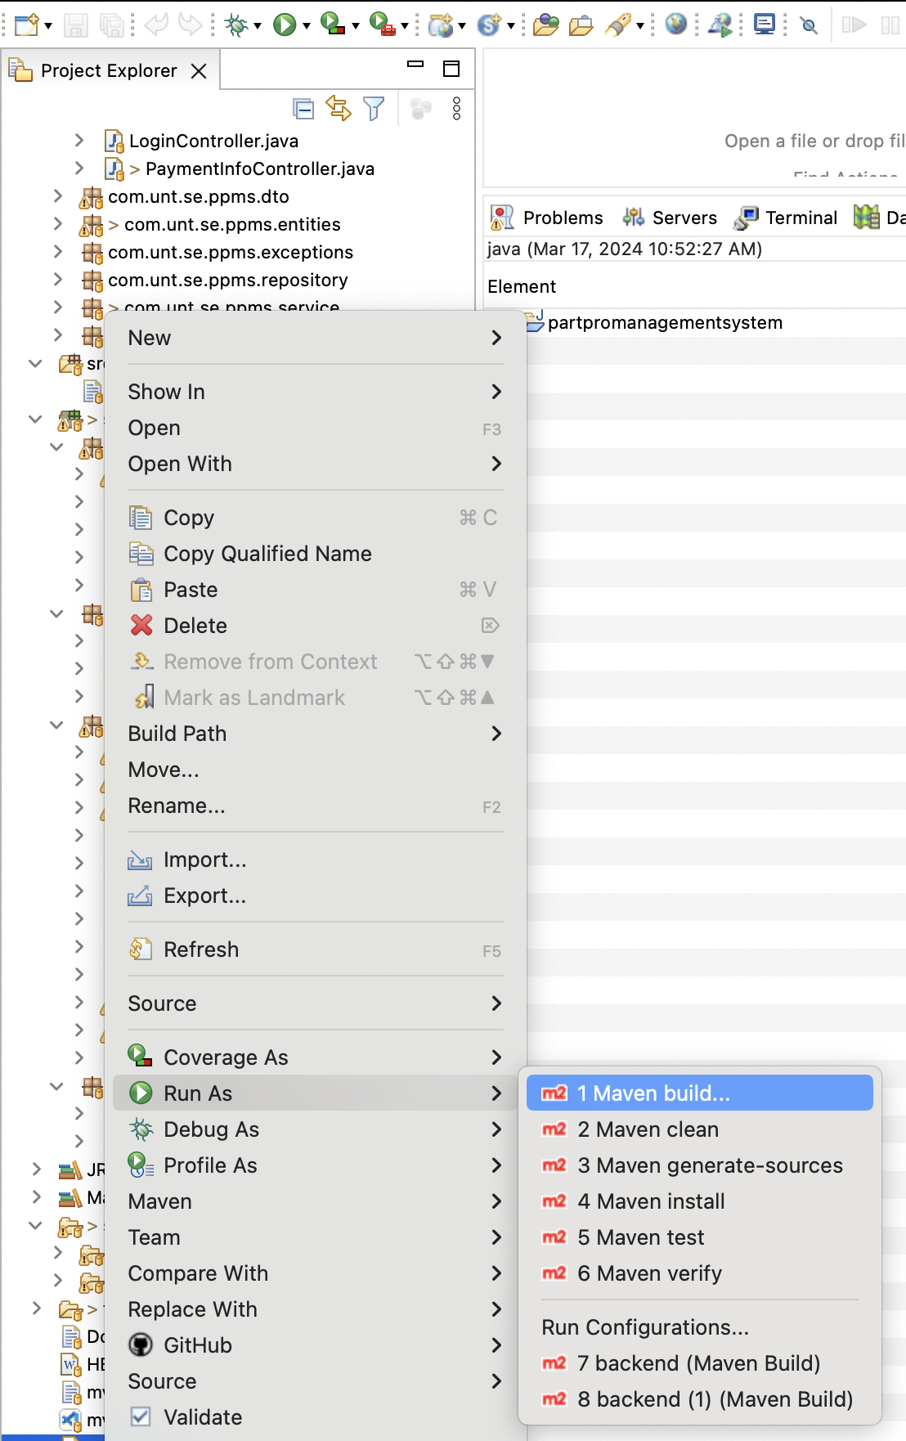

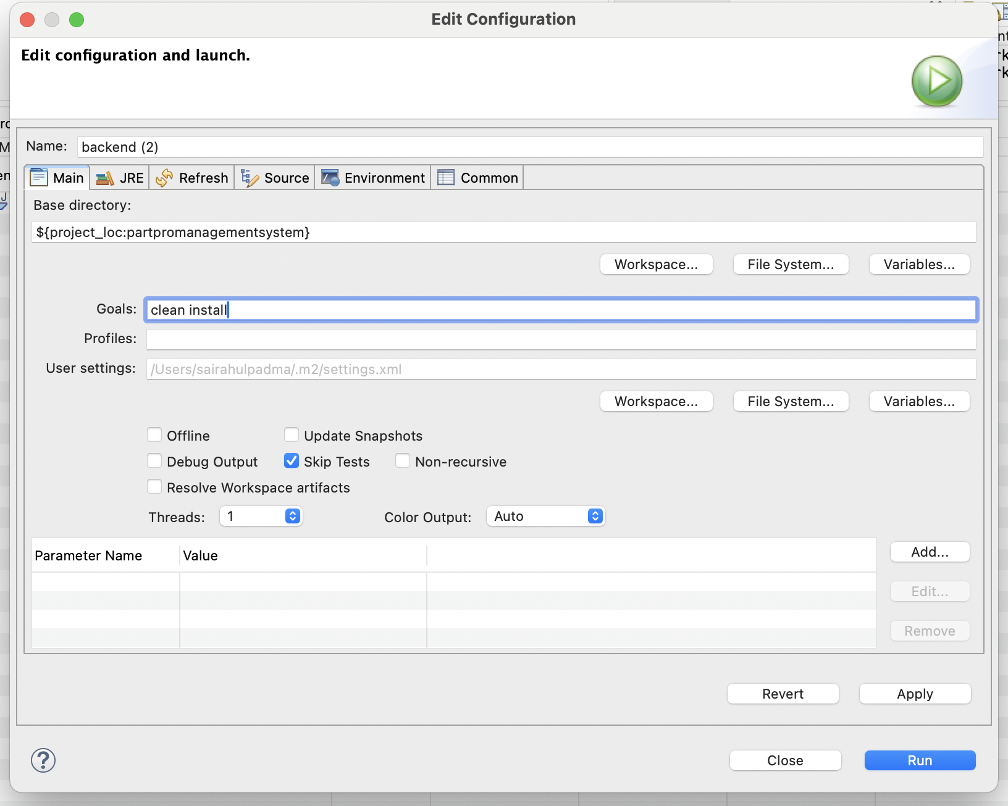

1. You would get the below output in the console.

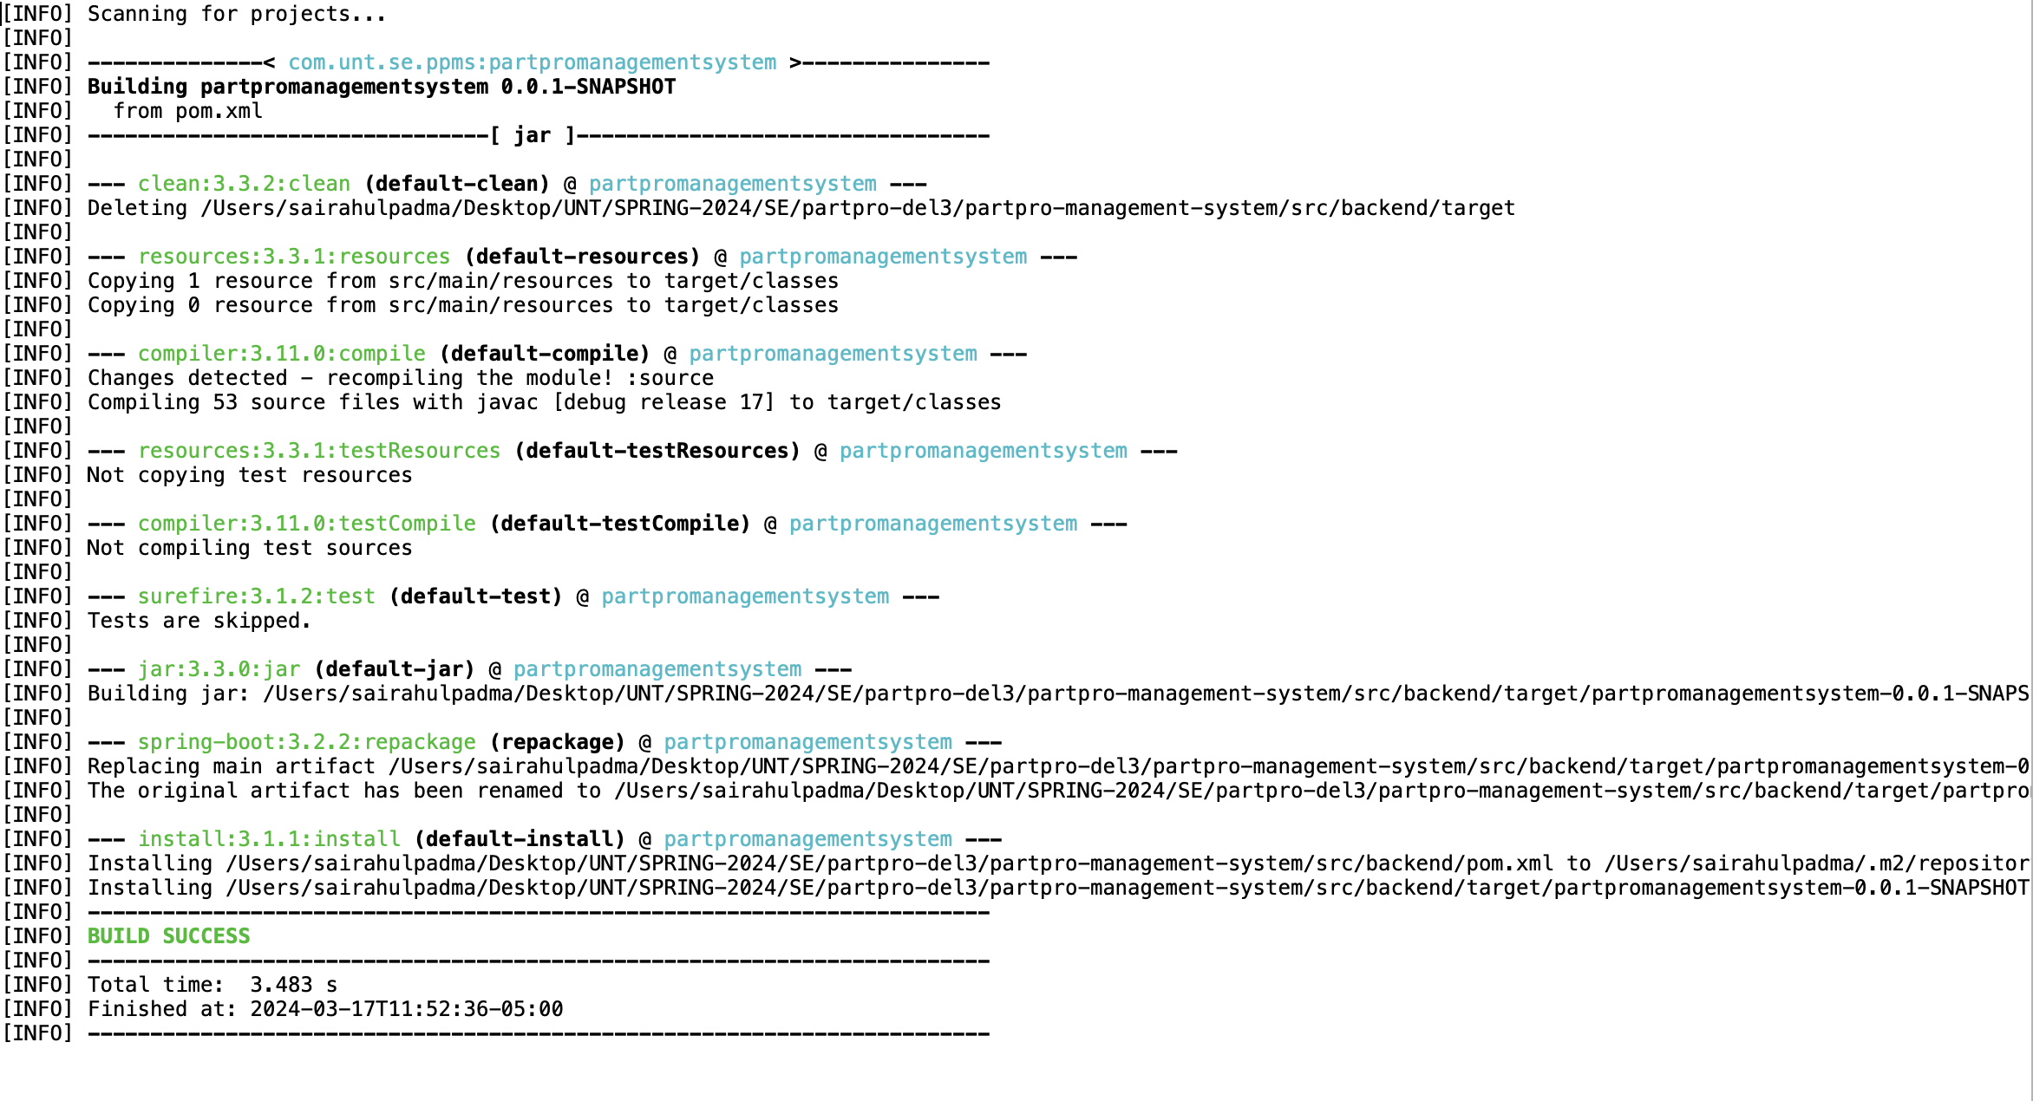

1. Update the username and password of your database credentials in application.properties which is resided in src/main/resources folder.
2. Run the java application once the application is compiled successfully.

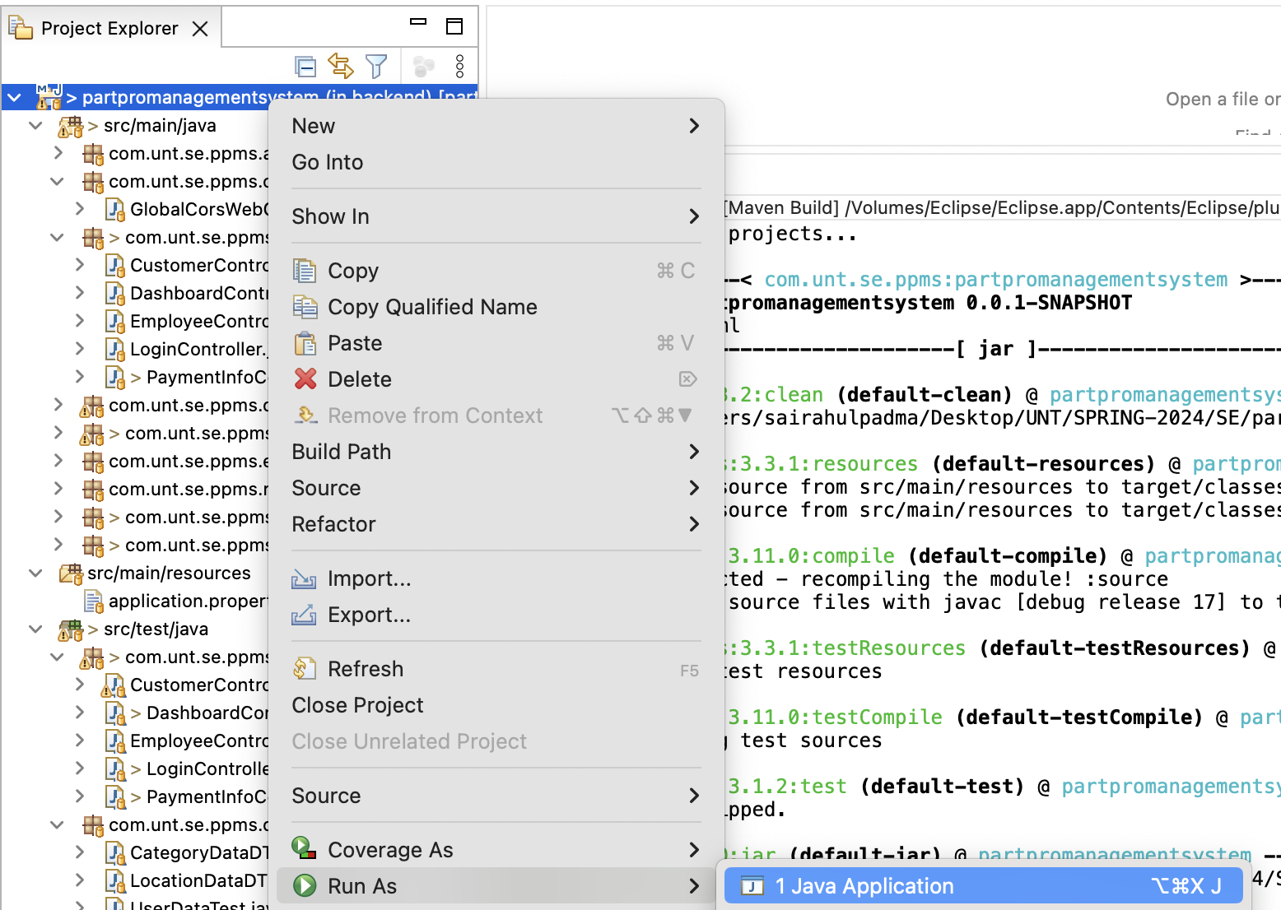

1. You would get the below output in the console and the application would be running on embedded tomcat server on 8080 port.



1. Test the API through postman once the back-end application is up and running. I have pasted sample API which was tested in postman.

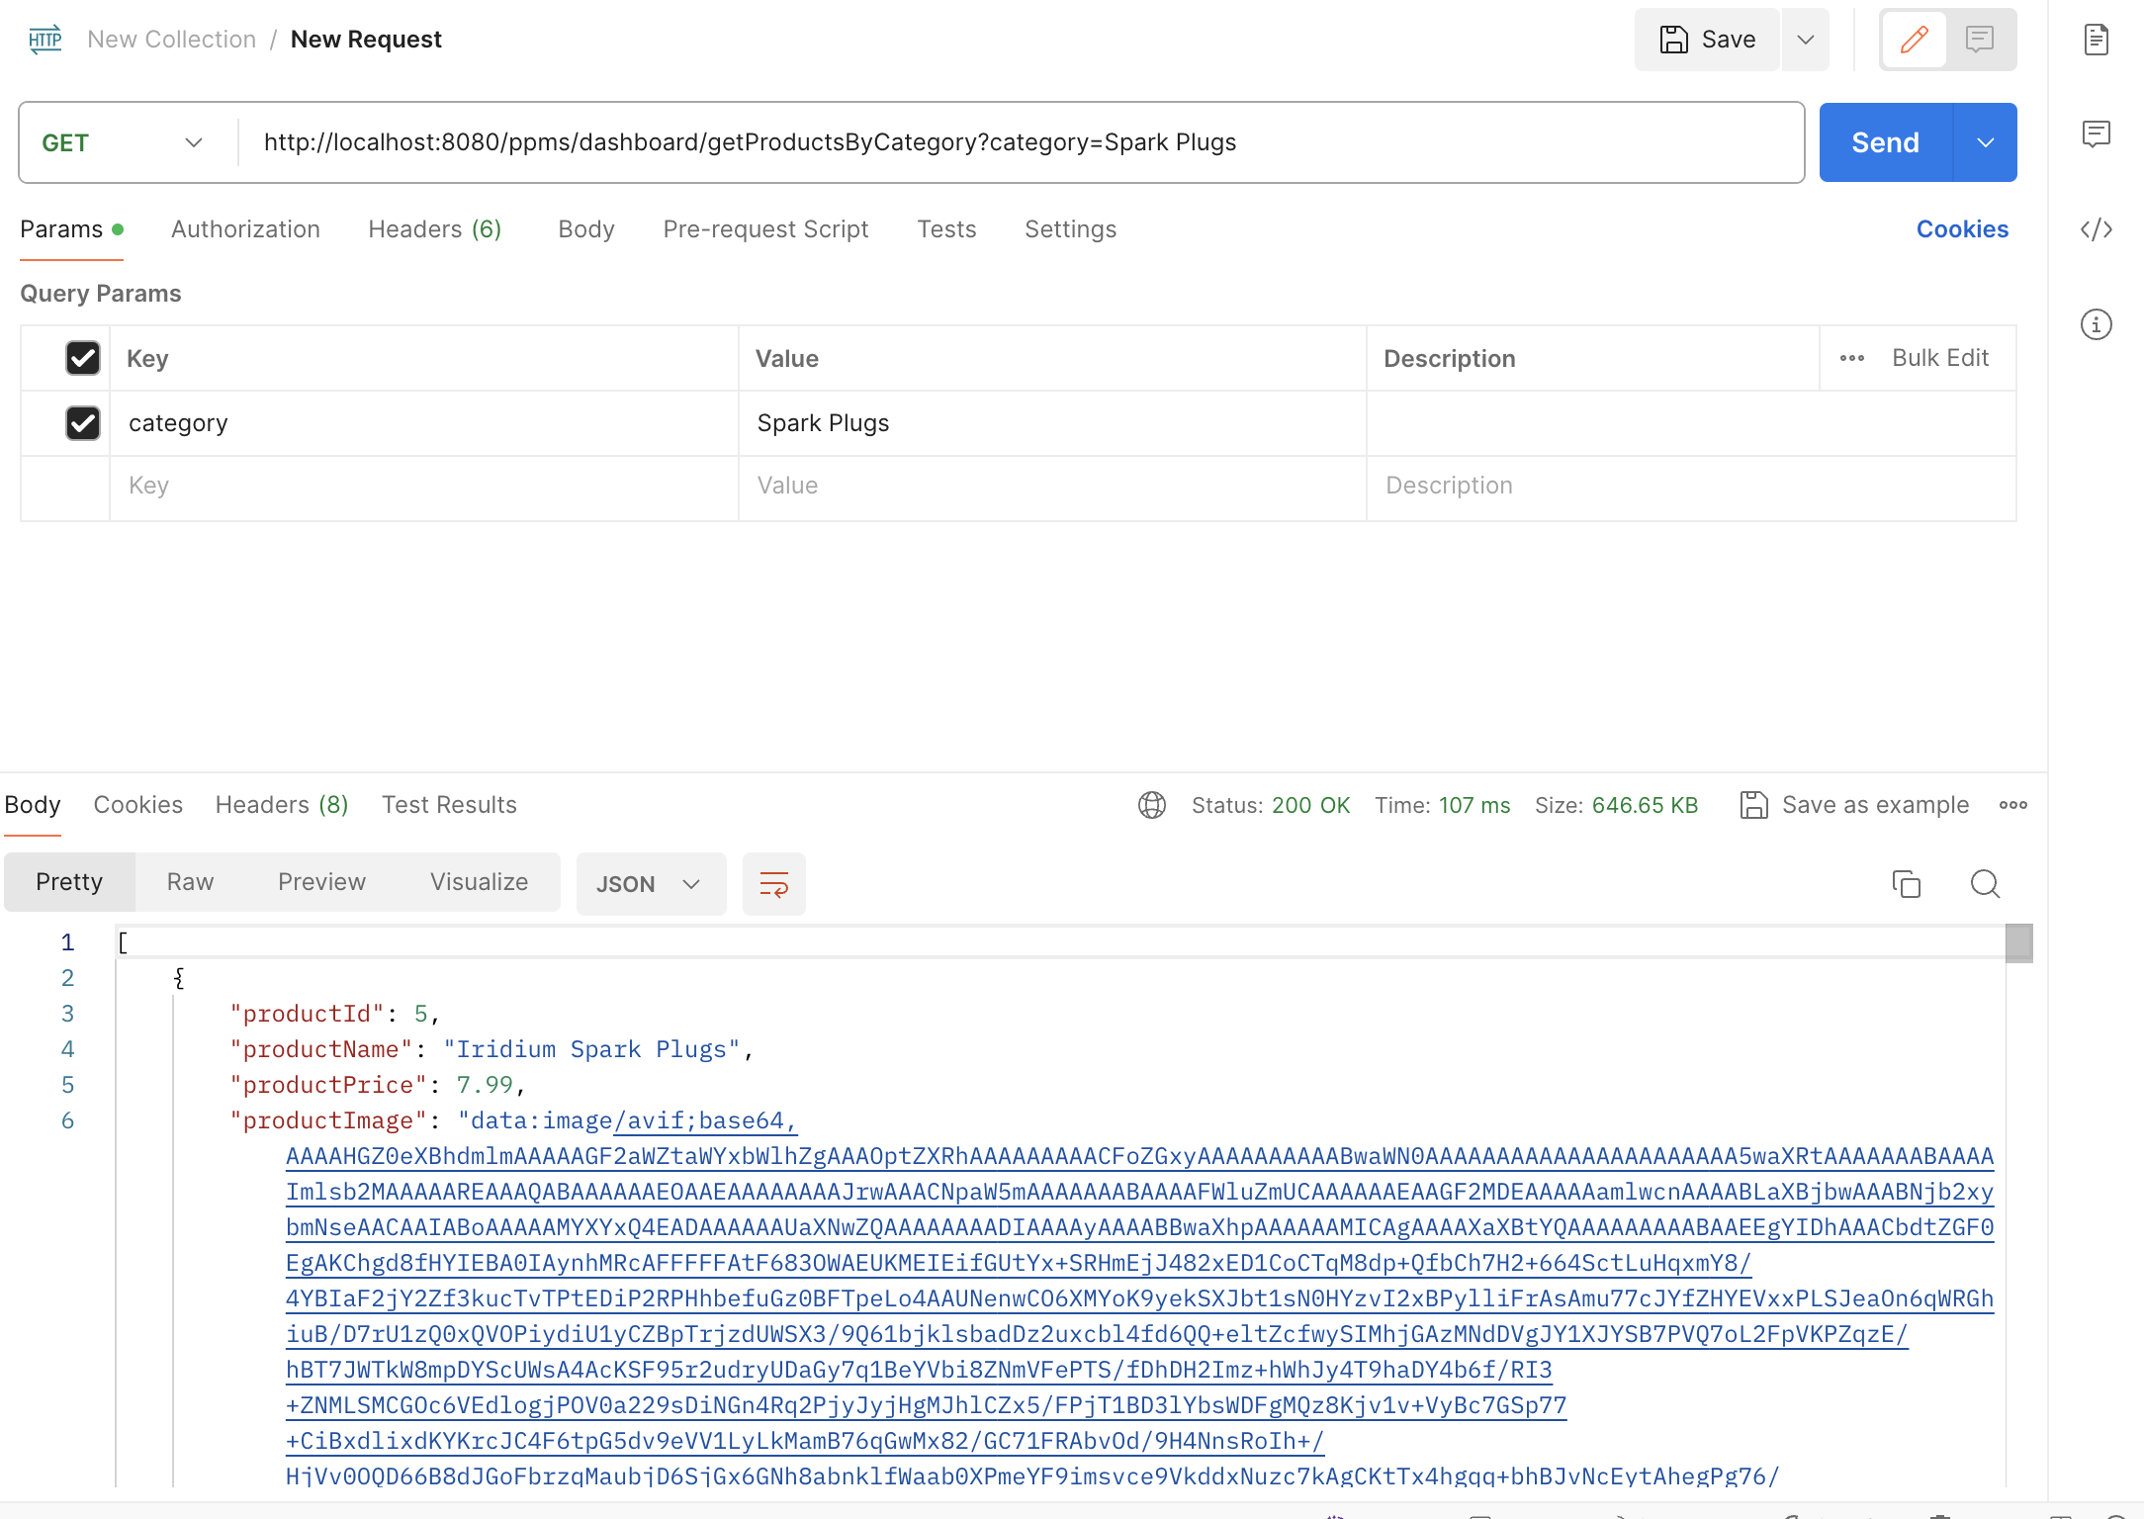

1. If you need all the API collection, Run the swagger link in your browser. We need to run the application before opening Swagger URL.

Swagger URL Link: <http://localhost:8080/swagger-ui/index.html>

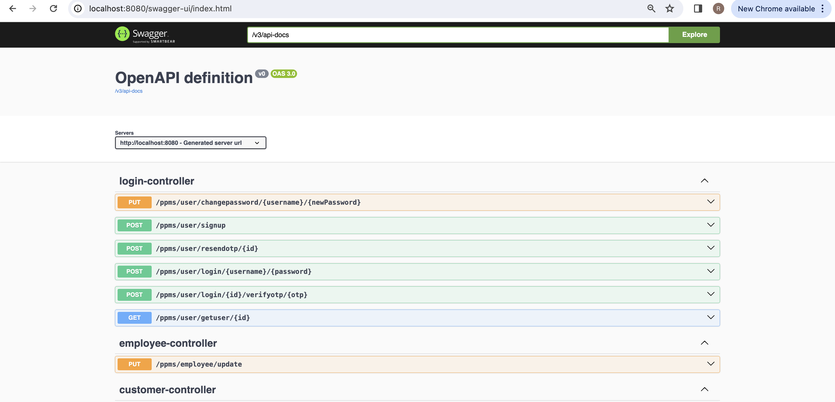

**For Backend Test cases**:

1. Compile the junit tests which were in src/test/java. Compile the test cases as shown below.

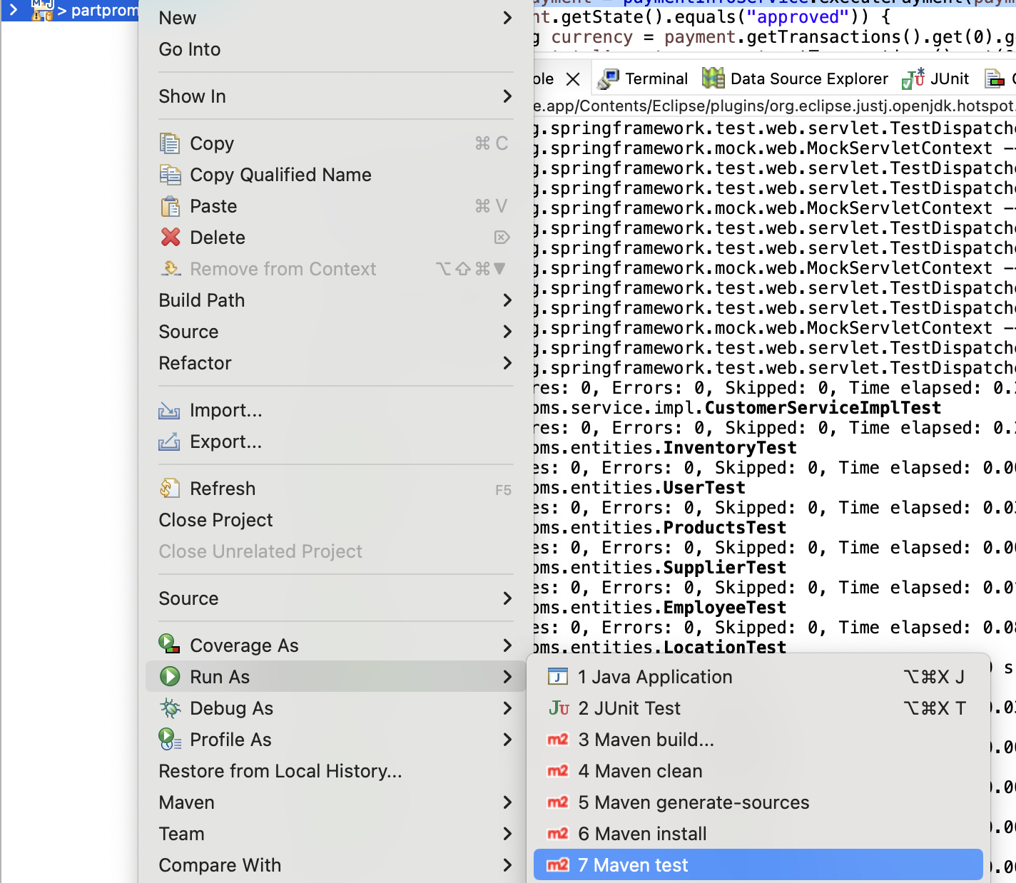

You would get the below output from console.

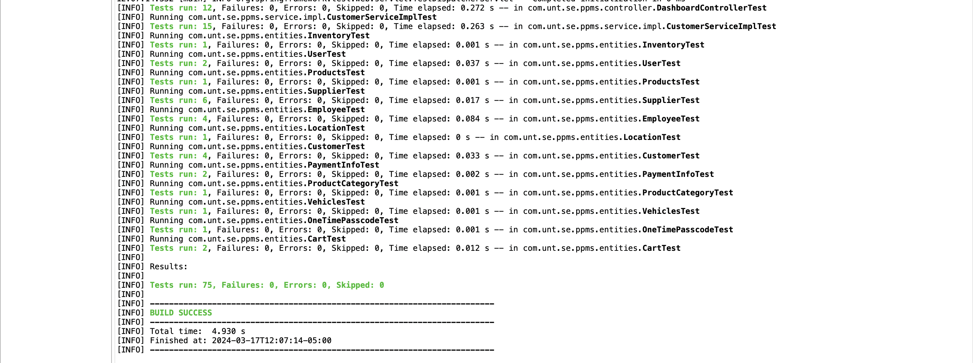

1. Run the junit tests which were in src/test/java. Run the test cases as shown below.

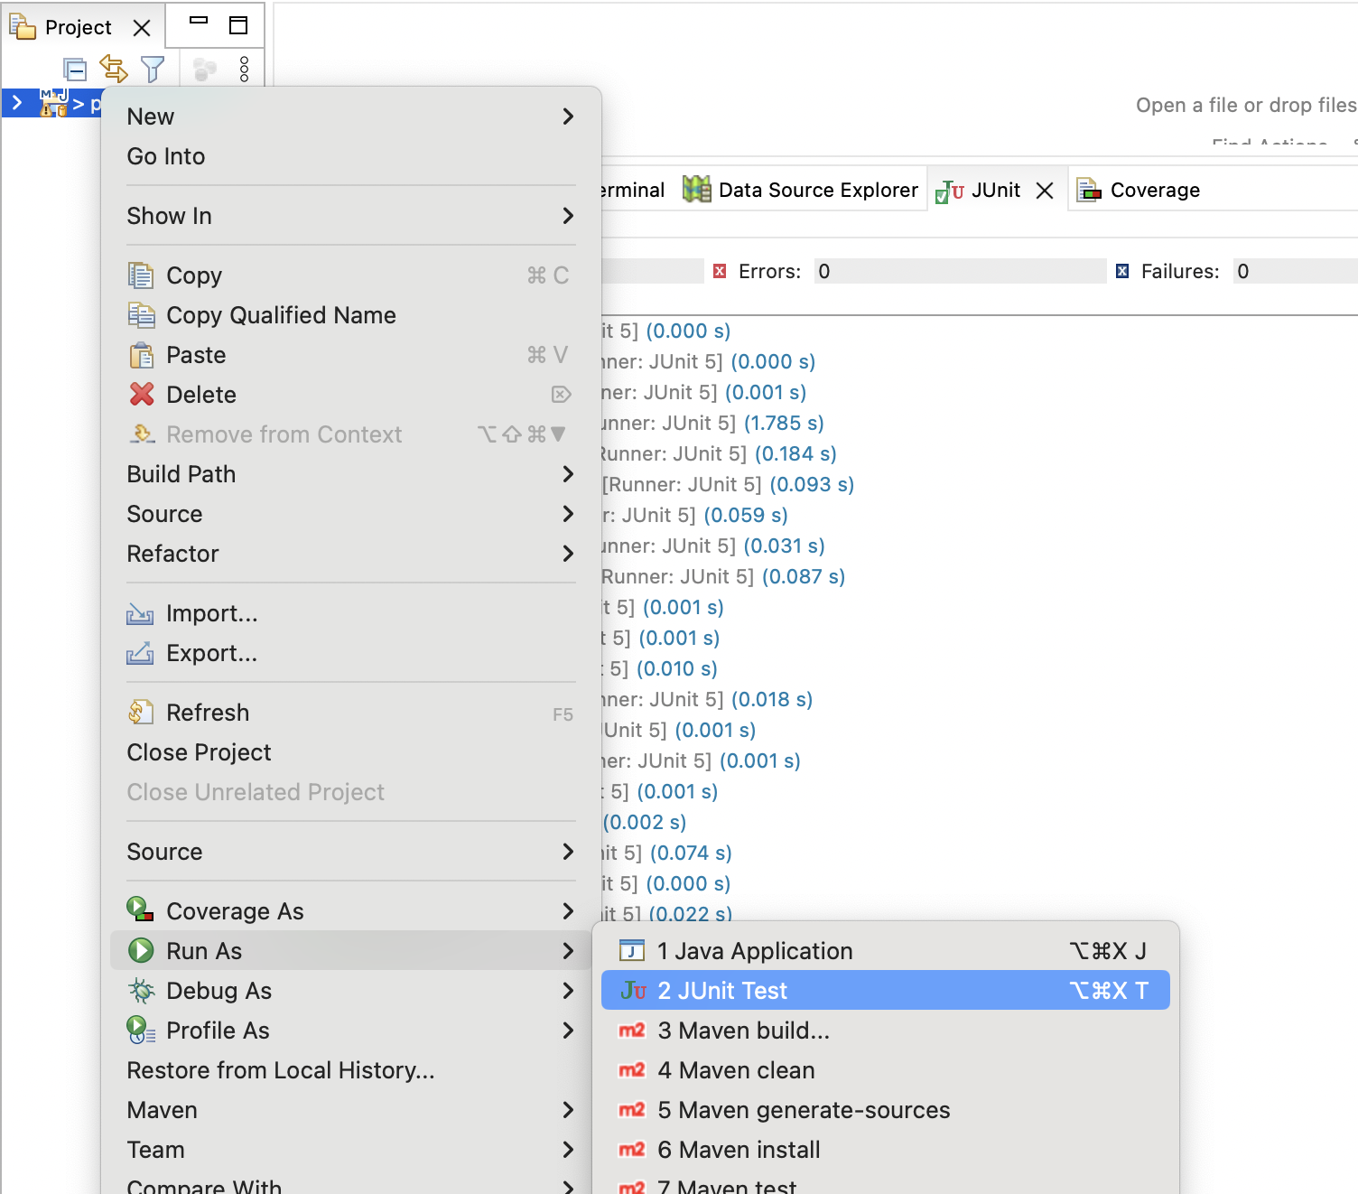

You would get the below output from the console.

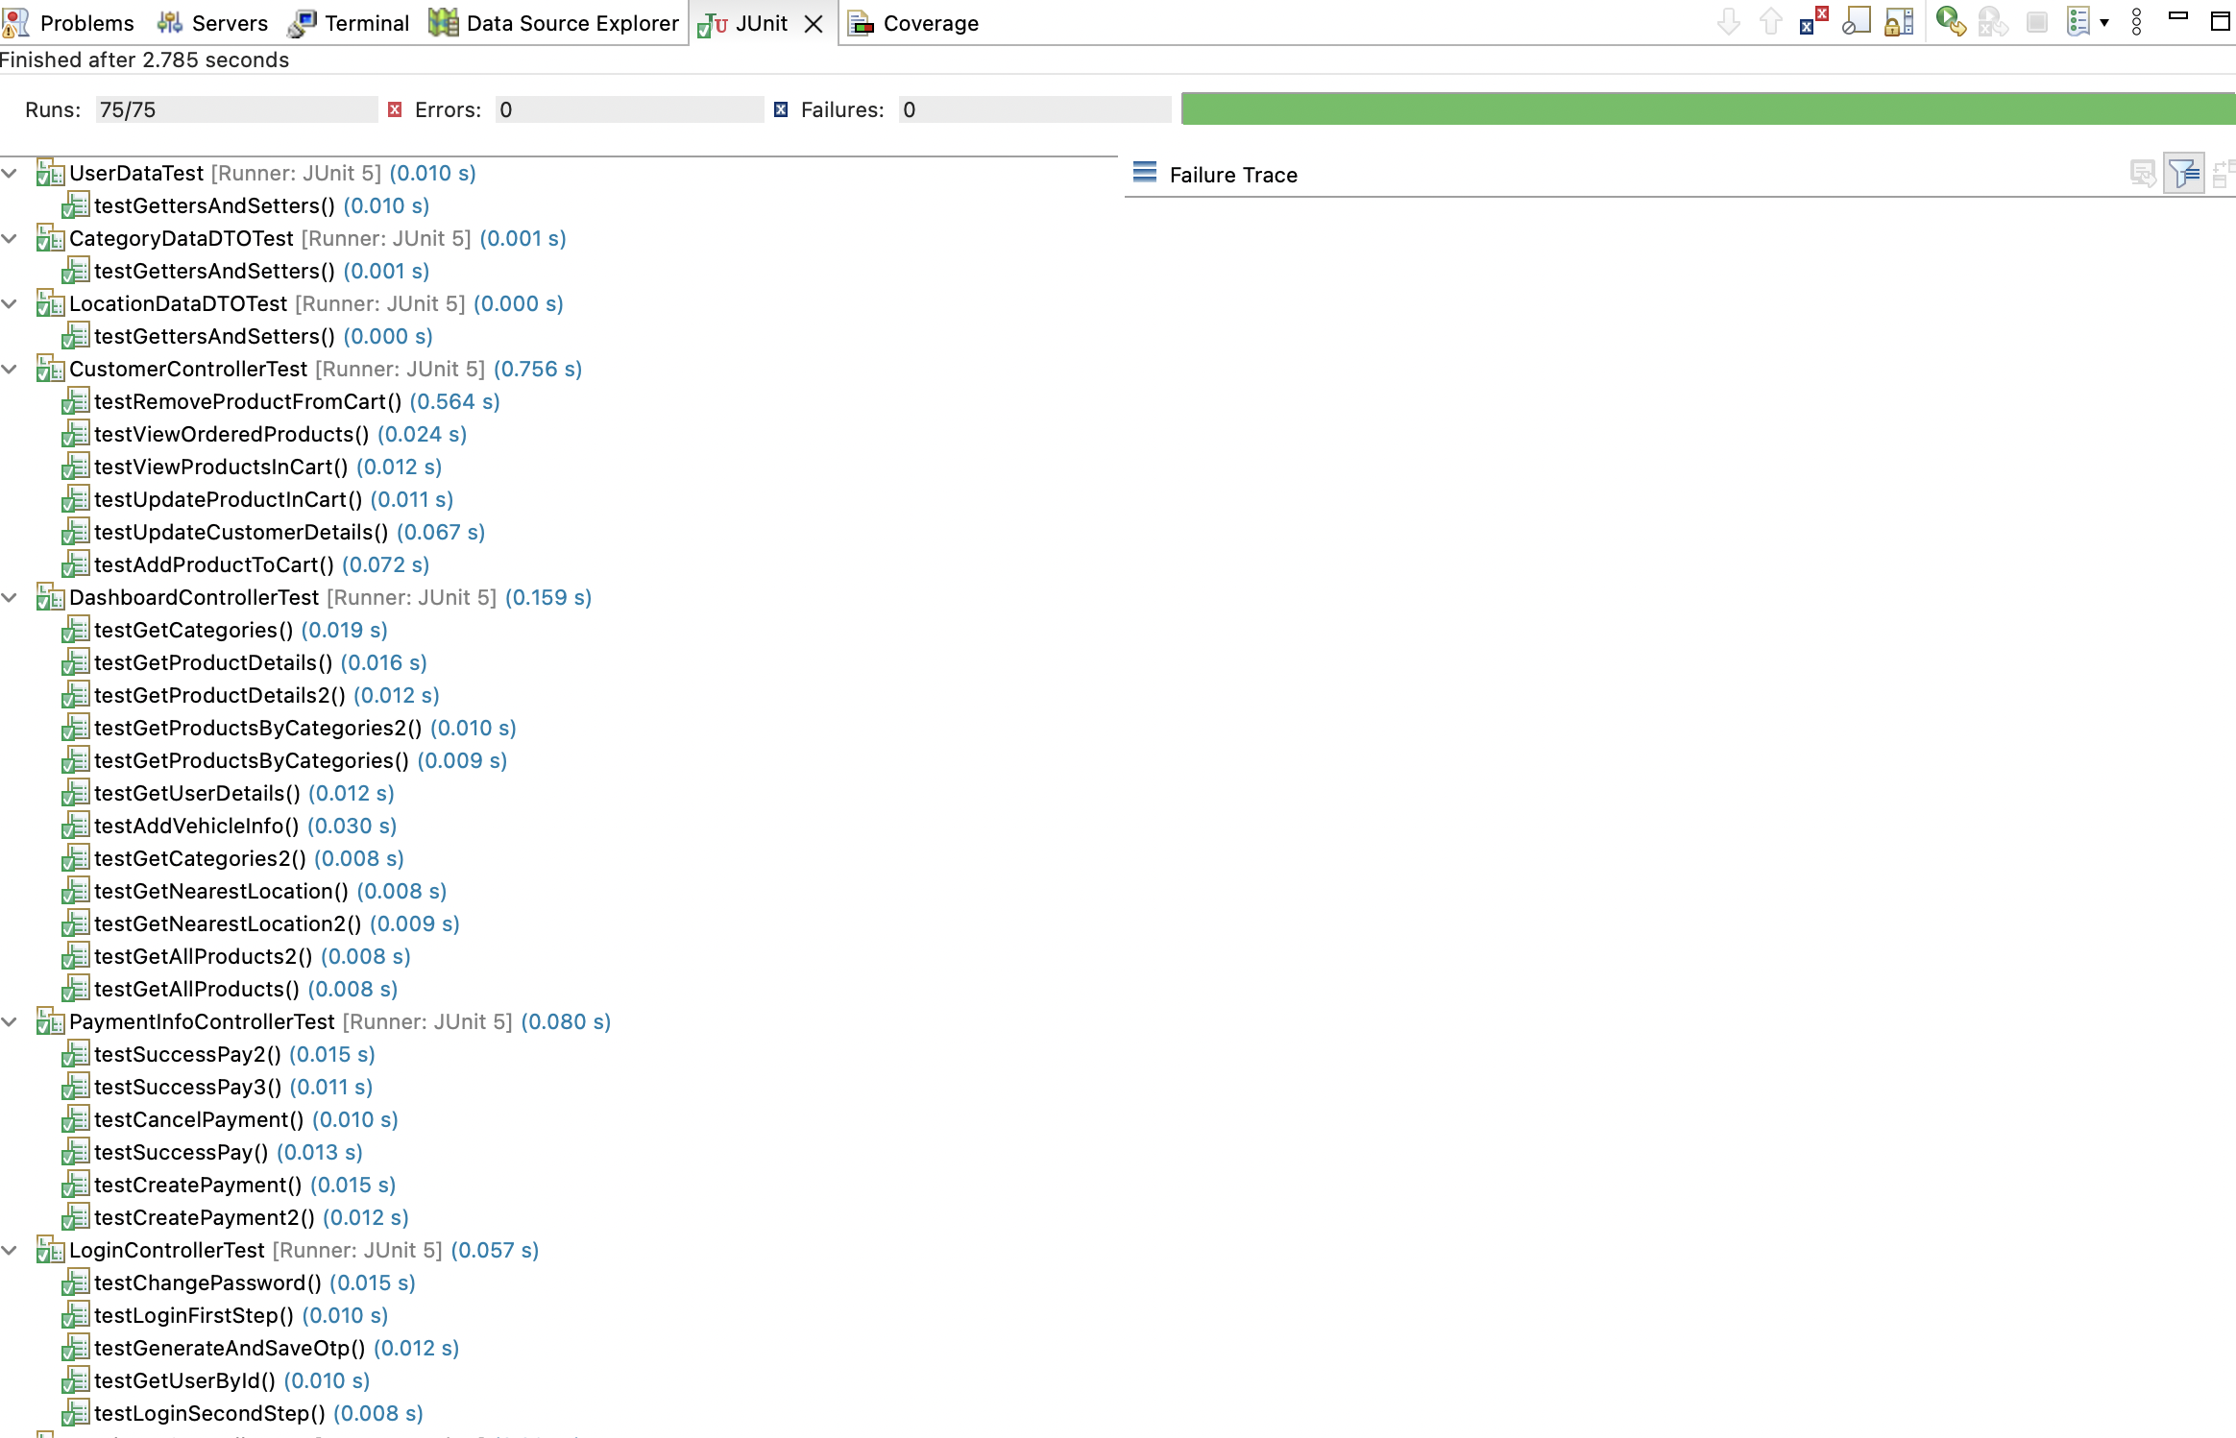

**For Front end:**

1. Install Node JS of version 14.x.x from below link based on OS type.

<https://nodejs.org/en/blog/release/v14.17.3>

1. Install visual studio code from below link based on OS type.

<https://code.visualstudio.com/download>

1. Open the terminal in vscode as shown below.

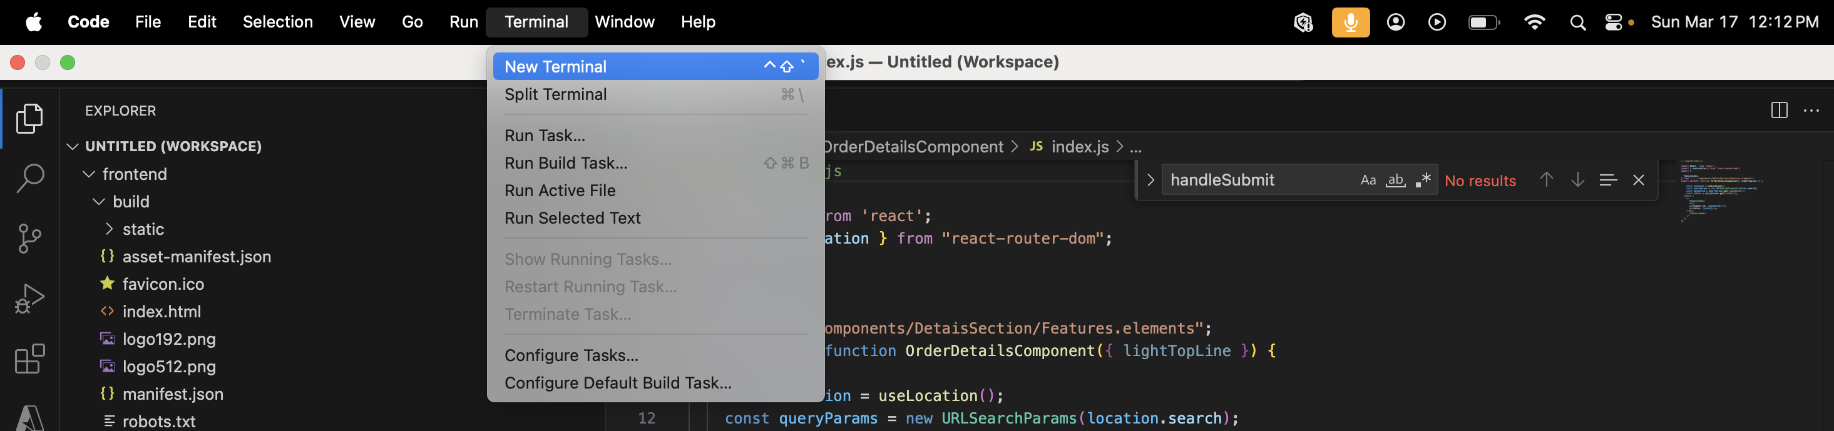

1. Install all the required dependencies by using npm install command and you would get the output as shown below.



1. Build the front end application by using command npm run build and you would get the output as shown below.

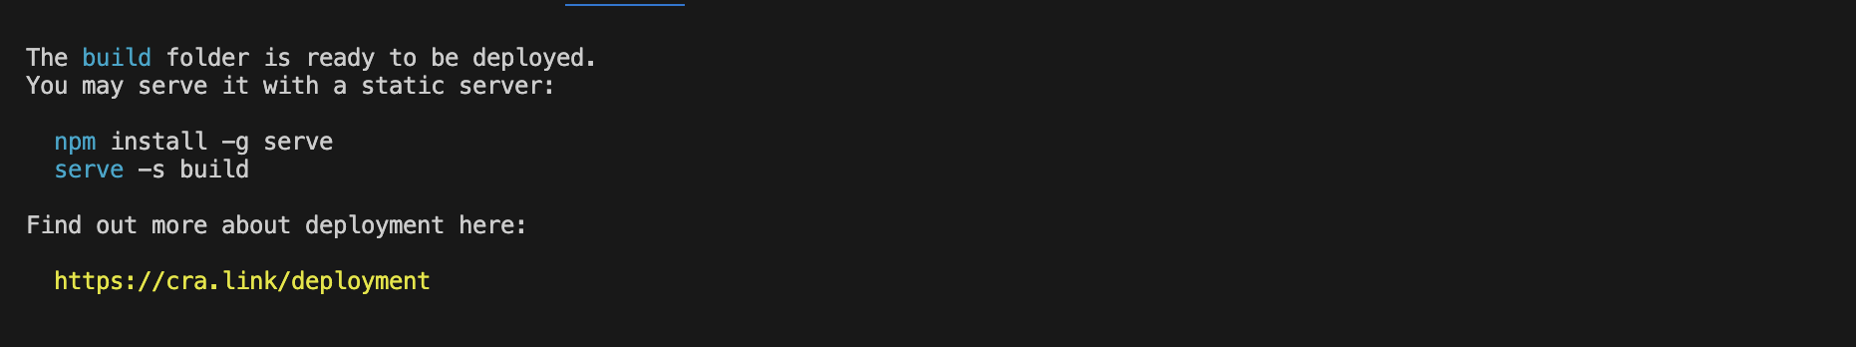

1. Start the front-end server by using this command npm start and when you access the application with the web URL ‘http://localhost:3000’ you would get the output as shown below. We can start using the application once the front-end application is up and running.

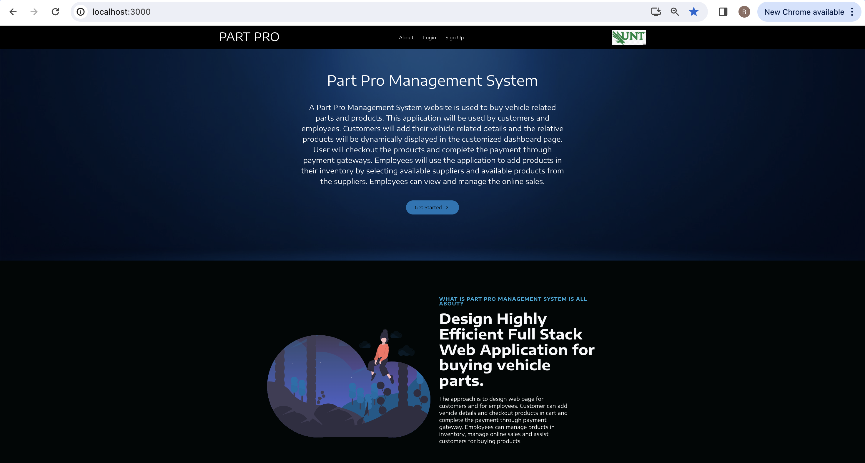

**Order Tracking Screen:**

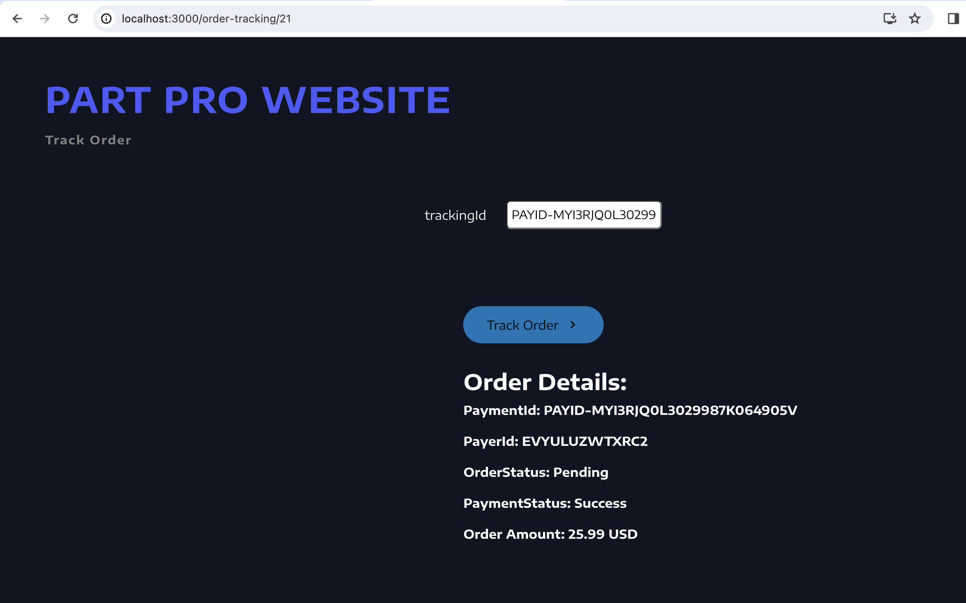

**Employee Dashboard Screen:**

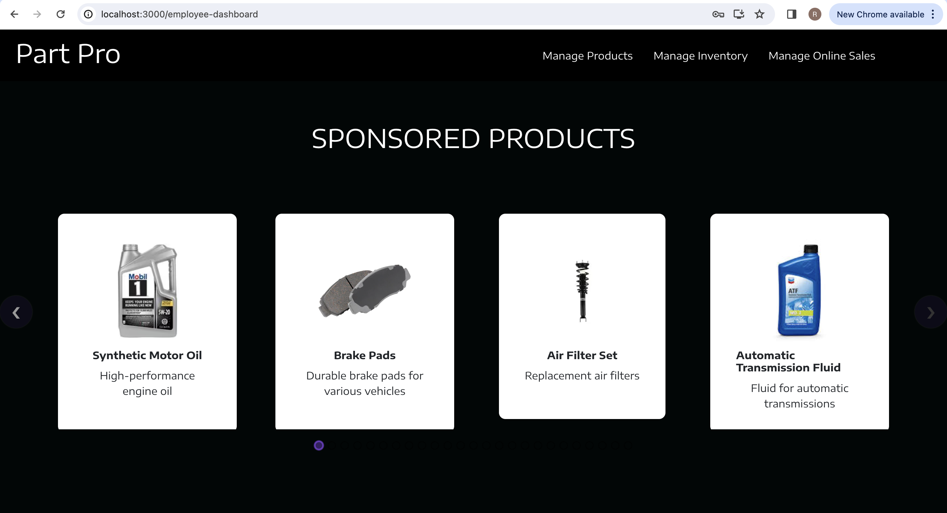

**Manage Products Screen:**

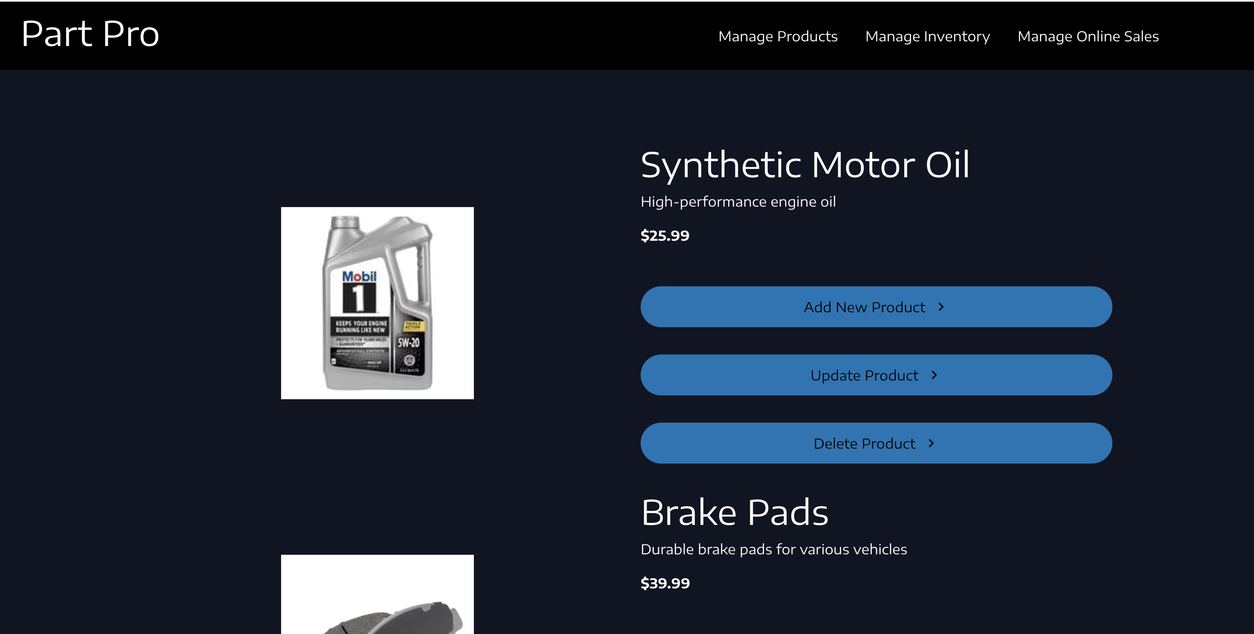

**Manage Inventory Screen:**

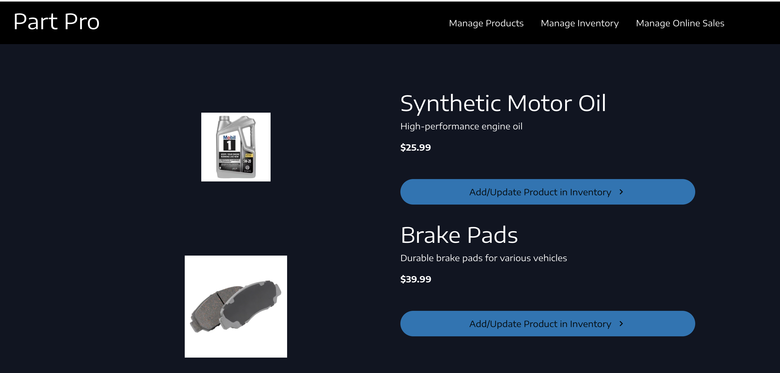

**Order Details Screen:**

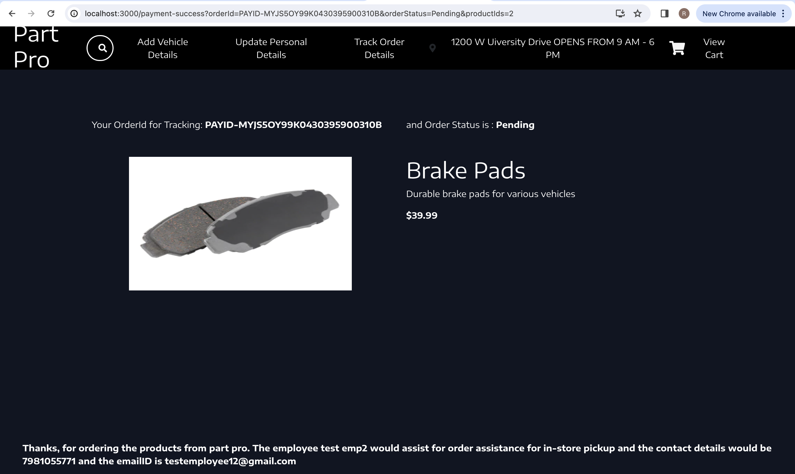

1. **Report User Manual**: We have worked on both front end and back end. I will include every step here.
2. Clone the code from the git repository.

git clone <https://github.com/padmarahul/partpro-management-system.git>

1. If the git is not recognized in your system, install git from the below link.

<https://git-scm.com/downloads>

1. After successful installation of git verify the git version through terminal and the command is git -v.



1. You need to install all required software for backend. Install eclipse IDE for back-end code development. Install Postman for API Testing. Install MySQL Workbench for data storage.

You can download all the mentioned software’s from the below links.

1. . If the OS is of windows, install eclipse from below link.

<https://www.eclipse.org/downloads/download.php?file=/technology/epp/downloads/release/2024-03/R/eclipse-jee-2024-03-R-win32-x86_64.zip>

If the OS is of Mac, install eclipse from below link.

<https://www.eclipse.org/downloads/download.php?file=/technology/epp/downloads/release/2024-03/R/eclipse-jee-2024-03-R-macosx-cocoa-aarch64.dmg>

MySQL Workbench Installation: <https://dev.mysql.com/downloads/workbench/>

Install MySQL Workbench 8.0.36 based on OS type.

Postman Installation: <https://www.postman.com/downloads/>

1. You need to install JDK for getting java environment and development kits. Install jdk from below link.

<https://www.oracle.com/java/technologies/javase/jdk21-archive-downloads.html>

Install java of version 21.0.2 based on OS type.

1. After successful installation of jdk verify the java version through terminal. And the commands are java –version and javac –version

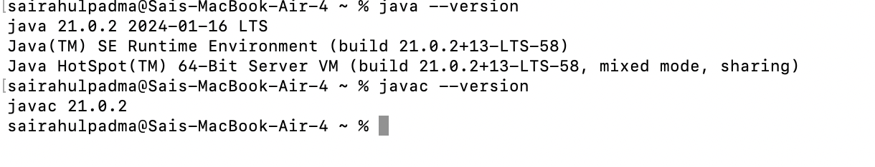

1. Go to the directory till src/backend and import the back-end repository into eclipse.

Click on File🡪 Import 🡪 Existing Maven Projects.

Add the root directory till src/backend and click Finsh. The back end code is imported successfully.

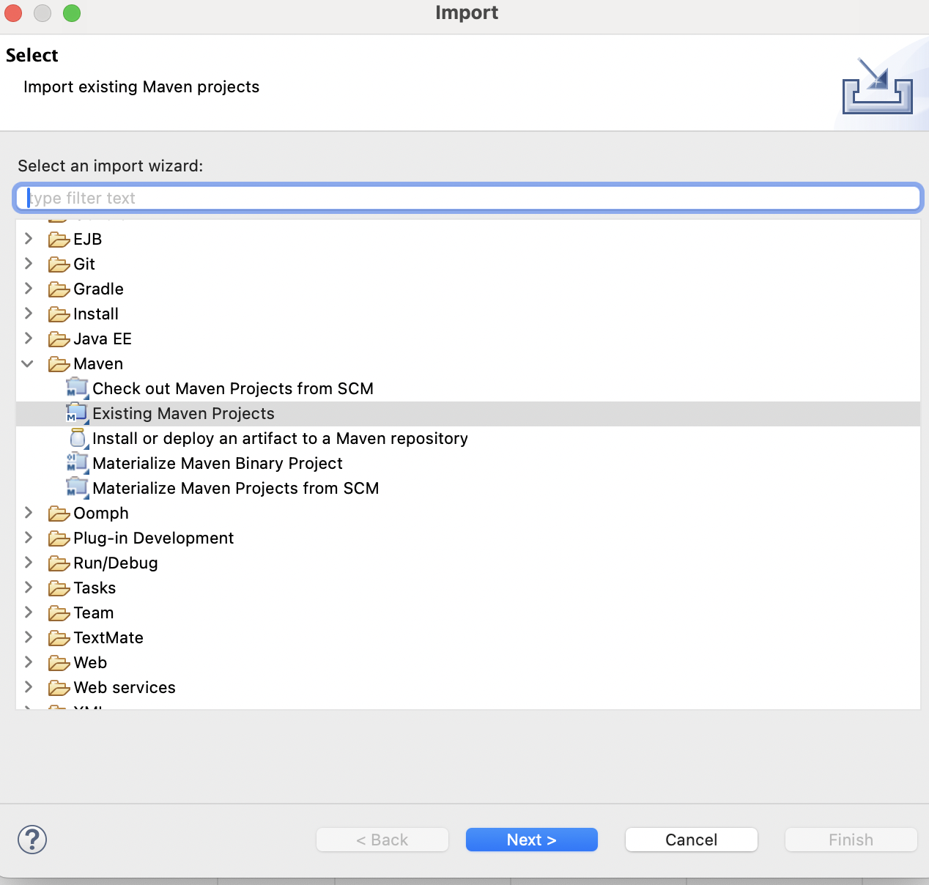

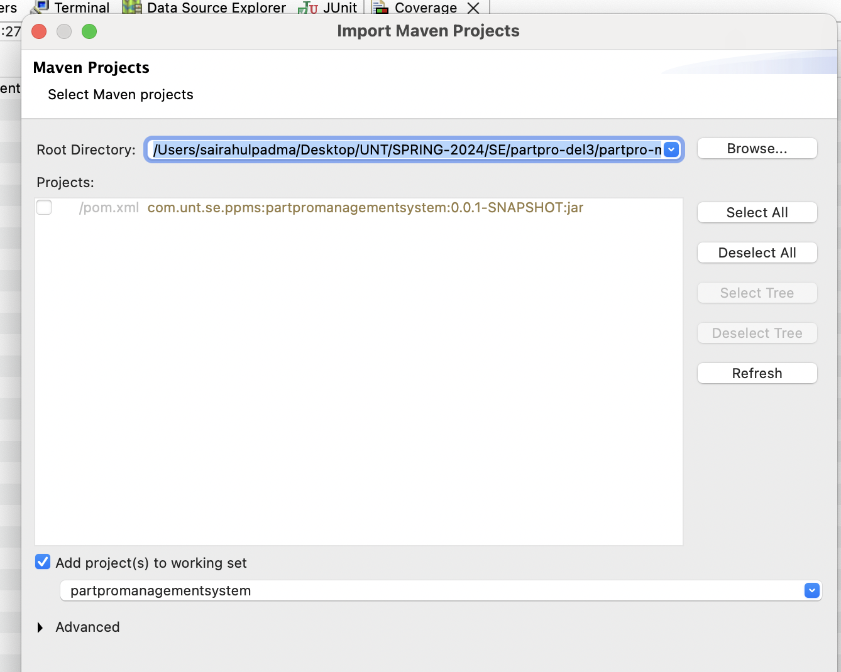

1. Once the application is up and running test the APIs through postman. We can also test all the API through swagger. The swagger is used to store all the API collection and this configuration is written in the back-end code. The swagger link would be running once the application is built successfully and the link is pasted below.

<http://localhost:8080/swagger-ui/index.html>

1. We can also test API through postman.

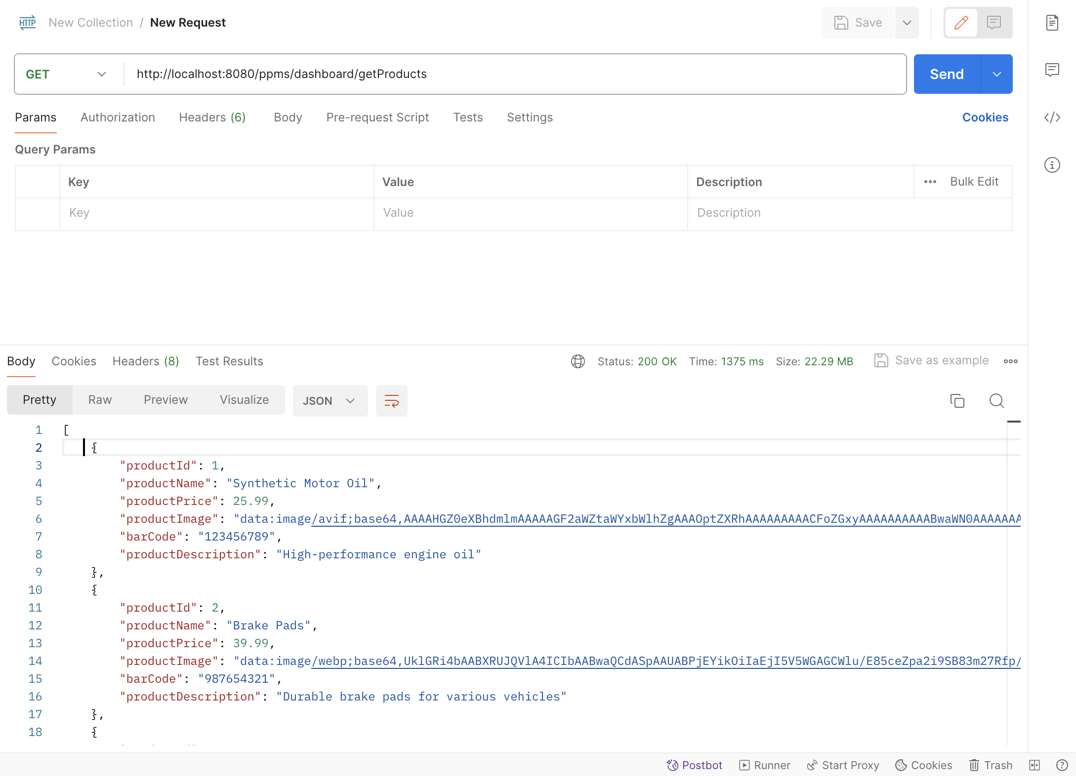

1. Now install the front-end software’s for working on front end code. Install the Node JS for running front end on web server and it installs all required dependencies. Install Visual studio code for front end code development.

Node JS Installation: <https://nodejs.org/en/blog/release/v14.17.3>

Install Node JS of 14.7.3 for compatibility.

Visual Studio Code Installation: <https://code.visualstudio.com>

1. Verify the node version after installation through terminal and the commands are node -v and npm -v

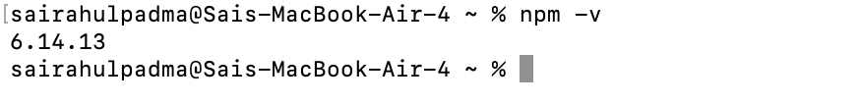

1. Go to the directory till src/frontend and import the front-end repository into vs code.

Click on File🡪 Add Folder to Workspace

Add the root directory till src/frontend and click Add. The front-end code is imported successfully.

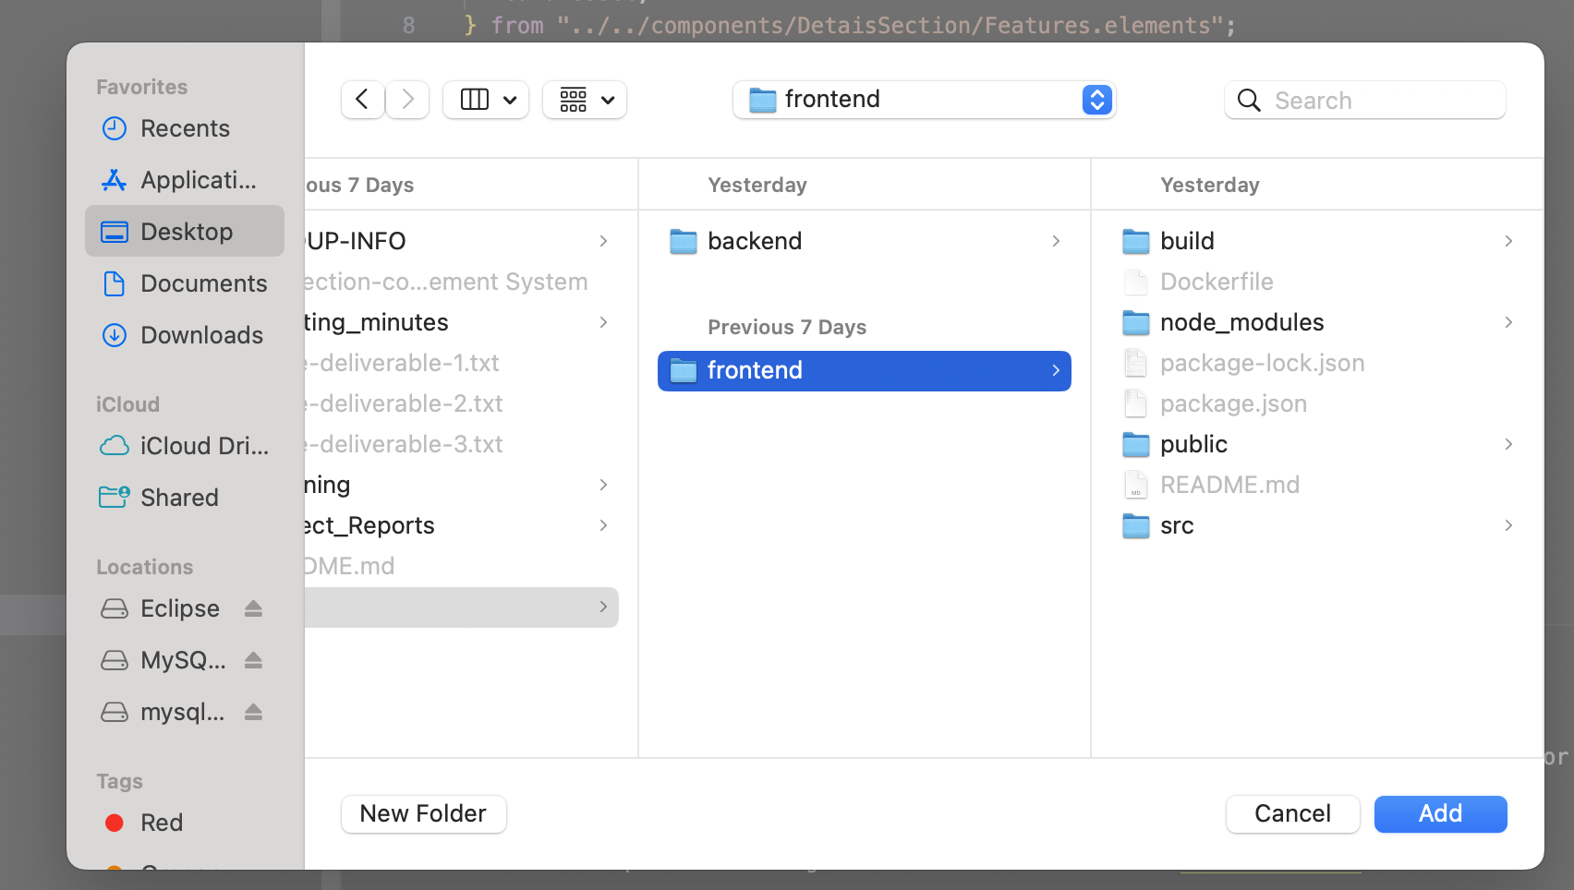

1. After the application is up and running use the application through web link. The link is pasted below.

<http://localhost:3000/>

1. Once user lands on home page, user could login into the application by clicking on Login in navbar. If the user is not created, click on signup button in the navbar. Once the user is created, login by providing username and password. The OTP popup would be opened. Enter the OTP which would be sent to your email address. The user would login into customer dashboard if the user is of customer. If the user is of employee, the user would be landed on employee dashboard.
2. The customer can click on track order details which is available on navbar once user lands on dashboard.
3. Customer can view order details by doing following actions. Click on any of the product on the dashboard. Click on add to cart button. Now click on ‘View Cart’ option which is available in nav bar. Click on ‘Complete Payment By PayPal’ button. The user would be redirected to PayPal developer account page. Once uses completes the payment, the user would be landed on order details screen.
4. Login with the user type as employee and employee type as Owner. This user would be able to view Manage Inventory and Manage Products links on nav bar. Once user clicks on manage inventory link, the user would land on manage inventory screen and when user clicks on add/update product to inventory button, the popup would be opened where user would be asked to enter quantity. Once user clicks on ‘Submit’, if the request is successful, user would land on dashboard. In the similar fashion, if the user clicks on manage products link, the user will land on manage products screen. If the user clicks on respective add/update/delete buttons, respective actions would be performed and if the request is successful, the user would be landed back to employee dashboard.
5. **Report Code Inspection Feedback:**

We have explained the core code functionalities which we have developed for development phase 1. They have provided good feedback like

**Feedback Points:**

1.The code was more modular and readable.

2. The code functionalities was independent of each other and if there is any bug inside any feature, It is easy to debug and resolve the bugs as earlier as possible. So, the source code has code maintainability.

3. They have done functional testing for the features they have developed.

4. The approach of API testing using swagger was a good initiative.

5. The component which they have created in front end is more reusable and flexible.

6. The API integration of back end with front end using Axios library is quite approach as the response would have headers, configurations details as well.

7. They have also done code coverage and it is greater than 90% which is quite good approach for unit testing.

**Suggestions Given:**

They have given few suggestions as well for the code we have checked in.

1. Code comments and documentation should be done better for the developed code

2. Integration and end to end UI testing should be done instead of functional tests which we have done in this phase.

3. Follow the naming and coding conventions for more code readability.

4. Need to work on more responsive designs which supports for mobile and tablet mode as well.

5. Need to work on logging mechanism as the code should be production ready.

**Actions Taken Based on Feedback and suggestions:**

1. We have accepted the suggestion like Code comments and documentation should be done better for the developed code and worked on as part of this development phase.
2. We have accepted the suggestion like Integration(end to end UI testing) and planned to work on and perform end to end testing along with functional tests as well.
3. We have accepted the suggestion like following naming and coding conventions and followed all the naming and coding conventions as part of this development phase.
4. We have rejected on working responsive designs because we have planned to work on dynamic web pages which should be responsive for desktop and web applications but we don’t have agenda or roadmap in the future development phases to work on responsive designs for mobile a tablet mode.
5. We have also rejected logging mechanism as this application is not used by real clients.
6. **Report Reflection:**

**Accomplishments:**

1. We have implemented all the features which are planned for development phase 2.
2. We have increased the code quality by performing exception handling and written test cases for all the features as part of this phase.
3. We have designed reusable components in front end which can be used in multiple pages.
4. We have used advanced CSS like styled components and material CSS.
5. We have used react redux hooks for better state management.

**Positive Aspects which went well:**

1. We have worked as team on the suggestions provided during code inspection feedback and listed down good suggestion that needs to be planned and rejected the other suggestions which are not required.
2. We have designed a structured, time lined and sequential development tasks and resolved all the blockers before the start of development.
3. We have done live and pair debugging if any of the team member faces issue during development.
4. We have improved code quality by following naming, coding conventions based on design coding standards.
5. We have modularized the code and code can be easily extensible and new features can be added easily because of structured design architecture.

**Areas of Improvement:**

1. User experience can be improved better which would increase the usability and better user experience for customers.
2. Code optimizations can be done in back end database calls and performance could be improved in front end by implementing lazy loading for fetching products on dashboard.
3. Code reviews and necessary code validations need to be done for each code merge request by arranging team meetings before the code gets merged.
4. **Report Member Contribution Table:**

|  |  |  |  |
| --- | --- | --- | --- |
| Member name | Contribution description | Overall Contribution (%) | Note  (if applicable) |
| Sai Rahul Padma | I have worked on code deployment inside azure VM, design of Use case, sequence , class diagrams, required database scripts execution, written unit tests for developed code. I have worked on employee service front end and back end changes. | 14.5 |  |
| Nikhita Muvva | I have worked on manage inventory related pages design, routes to manage inventory pages, service API integrations and required component and CSS designs. | 12.5 |  |
| Sai Samyuktha Paspuleti | I have worked on back-end product related API development and unit test cases, exception handling and service implementation. | 12 |  |
| Rishika Yalamanchili | I have worked on front end product related pages design, routes to product pages, service API integrations and required component and CSS designs. | 12 |  |
| Pavani Venigalla | I have worked on back-end order details and tracking orders related API development, unit test cases, exception handling and service implementation. | 12.5 |  |
| Himabindu Chunduri | I have worked on front end new Employee dashboard Navbar and changed existing components design, state management changes and required component and CSS designs. | 12 |  |
| Sneha Reddy Gangannagari | I have worked on back-end employee related API development, unit test cases, exception handling and service implementation. | 12.5 |  |
| Jhasha Sri Ede | I have worked on front end order details, tracking order related pages design, routes to respective pages, service API integrations and required component and CSS designs. | 12 |  |